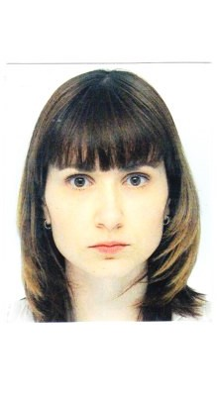
Curriculum Vitae
Name: Olga Sorokow
Address: Austria, 1040 Vienna, Margaretenstraße
41- 43/2/21
E-Mail: olga.kudr87@gmail.com
Telefon: +43 676 595 2557
Date of Birth: 30.11.1987
Marital Status: Married
Nationality: Russian
Work Permission: Yes

Education:
Since October 2014 Master Program „Technical Translation“
University of Vienna
Working languages: Russian, German, English

September 2011 – Bachelor degree „Translation Studies“
August 2014 University of Vienna,
Working languages: Russian, German, English

September 2005 – University Diploma, Specialist
July 2010 State Teachers’ Training University,
Department of Foreign Languages
Diploma with distinction
Internships:
September 2009 – English Teacher
November 2009 Secondary School N20, Ulyanovsk
February 2010 – German Teacher
March 2010 Secondary School N20, Ulyanovsk

June 2009 – August 2009, Teacher in Summer Camp
June 2008 – August 2008 DOC Severyanka, Krasnodarskij Kraj,Russian Federation
June 2007 – August 2007

Work Experience:
March 2015 - Executive Assistant to the CEO
„O&R Altpapier“, 1010 Vienna

September 2013 – Babysitter
July 2014 Andrea Zsutty, 1080 Vienna

May 2012 – March 2013 Babysitter
Nadja Holstein, 1130 Vienna

May 2010 – July 2011 Sales Assistant
F5 Jeans, 432072 Ulyanovsk, Russian Federation

September 2009 – Translator in Translation Agency „Perevod“ Ulyanovsk
September 2011 English, German and Russian translations

September 2005 – Private English Tutor
September 2011

Skills and Competences
Languages: Russian (native speaker C2), English (C1), German(C2)
PC: MS – Office, Outlook, Power Point
SDL-Trados, MemoQ
Driving Licence: Class B
Hobbies: Reading, Languages, Sports.

