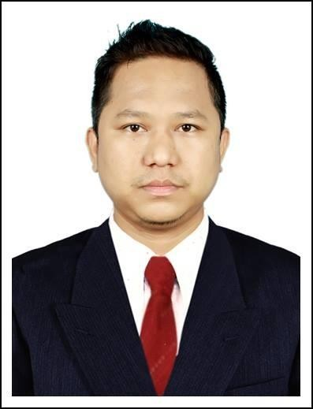
Nyan Wai Phyo
Mobile : (+959) 260446750

No.552, Panita Street, East Ywa Ma, Insein,
Yangon.

Objectives and Capabilities
nyanwaiphyo22383@gmail.com

- To secure a promising position that offers both a challenge and a good opportunity for growth.
- To work in a challenging position with progressive organization
- To utilize my working experience, professional skills, and creativity.
- To build my career in accounting field by utilizing all of my hard work and previous experiences.
- To work cooperatively with colleagues as well as independently.

Personal Information

Nationality Myanmar
Race Burmese
Gender Male
Date of Birth 22nd May 1983
Marital status Married
Father’s name U Kan Nyunt
Religion Buddhist
Passport No. MA303586
Languages English & Arabic

Education Background

  - B.A (History)
    - Western Yangon University Of Distance Education

Professional Certificate

Diploma in Business Management & Administration Course (ICM, UK) (Strategy First University)
  - Diploma in Sales & Marketing (ABE, UK)
  - F & B Service from Kandawgyi Hotel , Yangon , Myanmar

  - Microsoft Office System (Course Completed Certificate)

Employment History with Work Behaviors And Responsibilities

Jan 2011 – Dec 2011 | Service Personnel
 | Chatrium Hotel Yangon
Responsible in Customer Service

- Provide hospitality to Guests.

- Ongoing table maintenance.

- Making the guests feel welcome.

Aug 2012 – Mar 2013 | Customer Service Representative
 | Funcity Landmark Group, U.A.E
Responsible in Customer Service Field.

-Responsibilities to handle customer inquiries, complains and service requested.
-Handle angry callers, repair trust, locate resources for problem resolution.
Mar2013 to June 2014 | Customer Service Supervisor
 | Funcity Landmark Group, Sohar, Oman
Responsible in Customer Service Field.

-Provide excellent customer service to get customer satisfaction.
- Responsibilities to handle customer inquiries, complains and service requested.
- Handle angry callers, repair trust, locate resources for problem resolution.
- Interface daily with internal partners in fields services, operations.

Aug 2014 to Jul 2017 | Admin Officer
 | Zin Htet Construction and Transportation Co.,Ltd
Responsible in Admin Executive
-Answer calls from customers regarding their inquires and direct phone calls.
-Maintain contact lists.
-Provide general administrative and clerical support including mailing, scanning, faxing and copying to management.
-Schedule and coordinate meeting, appointments and travel arrangement for Director and Managers.
-Assist in resolving any administrative problems.
-Perform data entry and scan documents.
-Maintain electronic and hard copy filing system.
-Order office supplies and maintain office supplies for department.

Aug 2017 to Oct 2019 | Assistant Sales & Distribution Manager
 | Fintech Myanmar Co.,Ltd
Responsible in Assistant Manager

-Prepare routing plan and arrange ways for sales staffs

-Coordinate daily customer service operations

-Track the progress of weekly, monthly, quarterly and annual objectives

-Evaluate employee performance and identify hiring and training needs

-Supervise and motivate staff to perform their best

-Coach and support new and existing Sales Associates

-Suggest sales training programs and techniques

- Communicate with clients and evaluate their needs Analyze consumer

behavior and adjust product positioning Handle complaints from customers

- Provides sales vs. projection results by preparing and forwarding sales tracking reports.

- Maintains customer database by inputting customer profile and updates; preparing and distributing monthly reports.

- Prepares sales presentations by compiling data; developing presentation formats and materials.

Nov 2019 to Present | Sales Executive
 | Aya Bank ( Consumer Banking Dept;)
Responsible in Sales Executive

-B2B POS service to merchants.

-Manage key POS and partnership account.

-Organize regular merchant meetings to discuss for their requirements.

-Coordinate daily customer service operations

-Responsible to meet the monthly/weekly targets assigned by the management.

-Coach and support new and existing Sales Associates

-Suggest sales training programs and techniques

- Communicate with clients and evaluate their needs Analyze consumer behavior and adjust product positioning Handle complaints from customers

- Acquire Customers for Home Loan from external or dealers/agencies.

- Ensure proper guidelines to branches and documents of customers collected by branches.

- Ensure arrange the documents and pass to Loan Dept; and follow up the processes till the disbursement done.

PROFILE

  - Highly organized , dedicated with a positive attitude .
  - Self-motivated , independent and able to solve problem quickly and accurately.
  - Able to identify priorities .
  - Proficient in using available resources effectively .
  - Knowing own limit and copying well under pressure .
  - Able to establish and maintain smooth working relationship with people in multi- disciplinary team and work as a good team player .
  - People-oriented person with strong interpersonal and communication skill .
  - 8 years experience in customer service fields.

Other Information
Availability | ; | One month noticed
Expected salary | ; | Negotiable

