RESUME

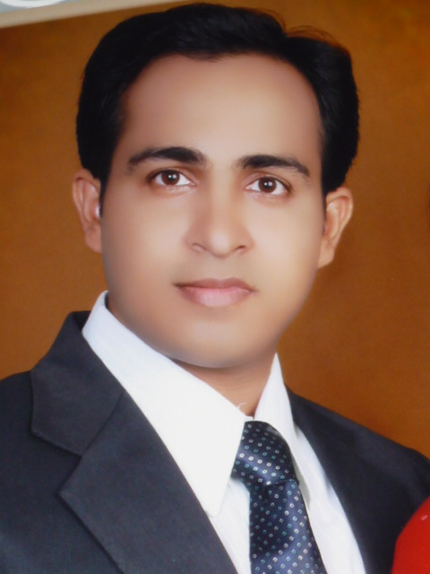

Nihar Kanta Panda

C/O – M Narsimha Reddy

B -265, House No – 4-13-35

HUDA Sainagar Colony, Vanasthalipuram

HYDERABAD70 PIN: 500070

Cell No: 9440563185

9014633184

Email: nihar.pnd@gmail.com

Career Objective

With an industry experience of more than 8years, I want to excel in the field of Television Journalism seeking a quality environment where my knowledge and skills could be shared, enriched and utilized optimally to attain the organizational goal.

Present Occupatin :-
Bulletin Producer (September 2003 till Date) Etv News (Oriya)

Current Job Profile

- Producing Bulletins as per the Requirement. Working as a team leader of copy-editors and video Editors.
- Teleconferencing with reporters to ensure proper coordination between the field and desk for the smooth run of Bulletins.
- Handling the output as per the assignments irrespective of regional, national or international news.
- Guiding the new-comers in order to extract error-free output.
- Furnishing story ideas for special stories and Episodes on current Affairs, sports, Festival etc.
- Coordinating with the Graphics department for special bang, inlay gfx plates, Tags and stings.
- Work as a check gate on special occasion to minimize the error in textual and visual content.

Professional Achievements

- Associated with nearly 100 special episodes on diverse topics and most of those have got tremendous viewers response.
- Played the role of Associate producer of the 12 hours long marathon programme on the counting day of General Election-2009 titled “Faisala-2009”.
- Handled individually and worked with the special team, for the series of special episodes on one Panchayat Election, Municipal Elections, two General Elections andstate assembly elections. (e.g. Mahasangram, Election watch, Election Express etc.)
- Conceptualized, Planned and Produced numbers of Special Episodes on sports, i.e. Football World cup, Cricket World cup, Olympics, Commonwealth Games, Asian Games etc. One of those worth mentioning in brief is, 2007 cricket world cup Curtain Raiser Episode named “Come on Team India” ( Live studio discussion (Hyderabad) and live band at Bhubaneswar)
- Handled some of the unique non news docu-feature on AIDS Awareness, Fakir Mohan Senapati’s “Rebati” which was widely appreciated by intellectuals and scholars.
- Played the Role of a Team Leader of copy editors in the crisis period (when nearly half of the senior member and performer of oriya news left the channel within a month)\ to give quality output and train them.
- Worked as an in house Trainer for the new recruits of ETV Oriya to let them understand the basics of News Channel. Played an Important role in evolving a proper system in the news desk for smooth functioning.

Technical knowledge
I have fair knowledge of the softwares used in and for broadcasting news environment that includes ;
- Leap Office
- I Leap
- Pixes
- Audacity (Voice over recording Softwares )
- VZRT – For creating slugs for Breaking and Update News, Video IDs, Template gfx.
- Fairly conversant with visual Editing softwares ( linear and non linear) i.e. Main Actor, AVID Pro, FCP ( Final Cut Pro)

Workshop
- Production Basics ( Creative Hub Hyderabad )
- Visual Editing
- Video Camera Operation
- Still Photography

Previous Job

- Presently working as the Bulletin Producer in ETV Oriya news and mostly responsible for the content.

- Worked as a Reporter for ANI (Asian News International) , Orissa (2002 June to Sept)

- Worked as an intern in Oriya daily The Sambad and DD Oriya News for six Month.

Professional and Educational Qualification

- Special Course in Television Journalism from IIMC (Indian Institute of Mass Communication)
- First class in Master of Journalism and Social Communication from “Centre for Development Education and Communication” (CEDEC) Bhubanewsar, Utkal University, Orissa
- Bachelor of Arts, with English ( Hons) and Philosophy, Samabalpur Univerity, Orissa

Other things I love to convey about

- Contributed a articles and write-ups to the “ETVIANS” (the in house journal of ETV Network), Oriya dailies, news blogs
- Won many prizes in debate and essay completion during school and college career.
- Sports have been my source of energy. Represented Utkal University in Inter-University Cricket Tournament, Won many Inter College Badminton Championships.
- As a part of my lover for Art, I do play Synthesizer, Flute, Compose and write songs.

Personal Profile

Name Nihar Kanta Panda
Father’s Name Achyuta Nanda Panda
D.O.B 06-06-1977
Sex - Male
Marital Status- Married
Languages Known- English, Hindi, Oriya, Sambalpuri
Nationality- Indian
Permanent Address At/PO: Patnagarsh, Near DFO Office
Dist – Balangir, 767025
Orissa
Declaration
I do here by declare that, all the above mentioned information is true to the best of my knowledge. I take full responsible for any kind of discrepancy.

Date:
Hyderabad. NIHAR KANTA PANDA

