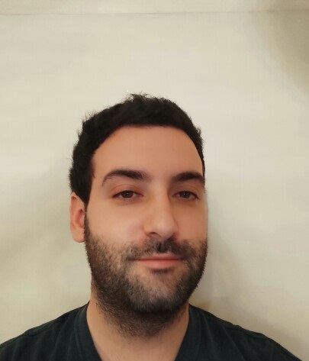

Dalmatinska 8, Kraljevo, Serbia

+381642541942

nemanjakv89@gmail.com

# Summary

Professor of English language and literature, currently finishing master’s degree in Semantics.

Proactive, customer-orientated translating professional with over 10 years of experience in translating documents and texts in various fields.

Nemanja Djurišić

# Highlights

* Translation
* Education
* Problem-solving
* Leadership
* Public speaking
* Teamwork
* Customer service

# Expierence

**TRANSLATOR, TEACHER** - 05/2010 to 02/2021

KRALJEVO, SERBIA

# Education

BACHELOR ENGLISH LANGUAGE AND LITERATURE TEACHER

**FACULTY OF PHILOSOPHY, UNIVERSITY OF PRIŠTINA, KOSOVSKA MITROVICA**

# Certifications

Certified teacher and translator.