Danish to English translator
Having lived in Denmark for almost half of my life and the other half in the UK, translating back and forth is second nature to me. This became prevalent when I switched my gymnasium degree for two years at an International Baccalaureate where one needed to be able to seamlessly switch back and forth between English and Danish. Since then I have attended University here in Denmark as well as in the UK majoring in History but have also studied English, politics, international relations, computing and European film studies to name a few. This gives me a valuable insight when it comes to translating.
While studying in the UK I worked for Scotland’s leading tourist agency for four years. Since finishing my degree at Copenhagen, I spent six months teaching English in China before returning to Denmark where I have taught English, mathematics and history at a local school. In the last year I have also worked as a freelance journalist for Scottish Television (STV) covering Denmark during the European Championships in football in Ukraine and Poland. I have worked as a Personal Assistant to the Managing Director and Scandinavian public relations officer for Datours Gozo. In my time off I have spent three years coaching youth elite football in the Copenhagen area for BK Skjold with three league titles to show for it.
I wish to offer my services in translating Danish to English and English to Danish specializing in the following categories:
Tourism and Travel, Journalism, Academic papers, Subtitling,
Government and Politics, Education, Pedagogy, Social Sciences, History, Sociology, Ethics,
Media, Multimedia, Games, Video Games, Gaming, Casino,
Cinema, Film, TV, Drama, General, Conversation, Greetings, Letters.
Yours sincerely

Neil Paterson
Paterson Translations

Paterson Translations, A.C Meyers Vænge 11 E 3th, 2450 Copenhagen, Denmark.

CV

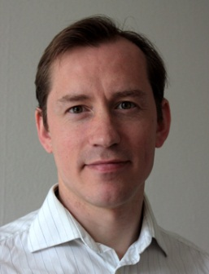
Personal Data
Neil Paterson  A.C. Meyers Vænge 11e, 3. th.  2450 København SV | Born:  21. Marts 1976
Tlf. 26464008
Mail:paterson.translations@gmail.com

Employment History
2012- founded Paterson Translations, freelance translation offering Danish to English & English to Danish translation.
2012 - Freelance journalist for Scottish Television, STV
2012 - P. A and Scandanavian officer for DA Gozo tours Scandinavian department
2007 - 2011 English teacher for Langelineskolen
2005 - 2006 English teacher at Suining Nr. 1 Middle School, Sichuan provinsen, for the Wan Cheng Int. Education Center, China
2005 - 2005 Sales rep for Cobra Sport, Copenhagen
2002 - 2005 Sales and Communication employee, Datours, Culross, Scotland -UK

Education
MA in History at Copenhagen University - Denmark History and Politics Aberdeen University, Aberdeen - Scotland
International Baccalurate, Birkerød Gymnasium - Denmark

Languages
English Native tounge
Danish Fluent tounge

CAT Tools
Trados Studio 2011
Wordfast

