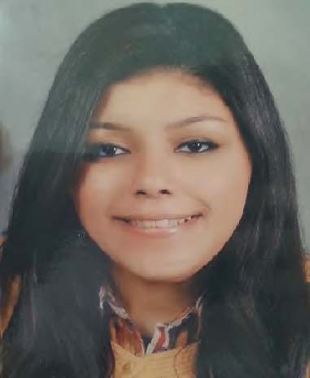

Nada Hesham Mohamed Zaki

Address: Kafr Abdou, 17Amir El Behar Street, Alexandria, Egypt.

Mob: 002-01115161768

Phone: (03) 5429-939

E-mail: Nido_h_z@hotmail.com

Nada.h.zaki@sce.aucegypt.edu

Education:

- Graduate from Faculty of Arts-English department, Alexandria university 2016

- National education (Thanaweya Amma) with a final average of 90%

- Primary, Middle and High School at Riada Language School (RLS), Alexandria

Courses:

- Finished foundation diploma in Translation and Interpreting at The American University in Cairo (2017).

- Recently finished taking Professional Legal & UN translation diploma at SCE, American University in Cairo (AUC).

- Upper intermediate conversation course at British Council

Career:

- Ex-member of the non-profitable charitable organization called Alpha Leo Club of Alexandria (2010-2013)

- Member of non-profitable charitable organization called Leo Club of Alexandria (2013- 2015)

- Worked at Unique Legal Translation (October 2018- October 2019)

Skills and knowledge gained:

- IT skills

- Windows

- Microsoft Office

- Time Management

- Leadership skills

- Problem-solving skills

- Communication skills(The ability to deal with various types of people successfully to achieve my goal)

- Negotiation skills

Personal skills:

- Ambitious

- Flexible

- Trustworthy

- Hard working

- Quick learner

- Patient

Languages:

- Arabic: Mother tongue language

- English: Fluent

