Mostafa Abdelrahman
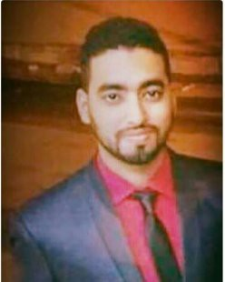
P
ERSONAL
D
ATA
Full Name:
Mostafa Mohamed Abdelrahman
Date of Birth:
17
th
of August 1993
Nationality:
Egypt
Marital Status:
Married
Location:
Ain Shams, Cairo, Egypt
C
ONTACT
I
NFO
Mobile:
01017757255
Phone: 022991905
Email: mustafa.gunner93@gmail.com
Facebook: https://www.facebook.com/MostafaAbdlrahman

PROFESSIONALEXPERIENCE
Sep 2016 to Present  (1 year and 1 month) | Customer Care Advisor at Vodafone UK Cairo, Egypt.  Industry: Telecommunications. Company Size: More than 1000 employees
Jun 2016 to Aug 2016  (2 months) | Sales Excutive at Orange Advertising Middle East Cairo, Egypt.  Industry: Marketing and Advertising. Company Size: 11-50 employees
Aug 2011 to Aug 2014  (3 years)  EDUCATION | Movies Translator at Myegy.com Egypt.  Industry: Online Media
2012 - 2015 | Bachelor’s Degree in Geography Ain Shams University, Egypt.  Overall Grade: Very Good

LANGUAGES

- English: Advanced.
- German: Basic.
1

AREASOFEXPERTISE

•Geography, Customer Care and Translation.

KEYSKILLS

Planner, Problem Solver, Flexible / Adaptive, Handles Stress, Team Player

LIKES

I like Travelling, Reading and Planning.

