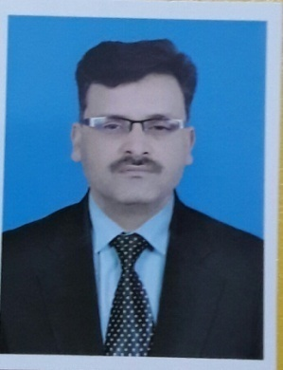
Muhammad Ismail Qureshi
Translation/Interpretation/Transcription/Editing/Proofreading/Review
Work Level: Professional
0ver 20 years of Experience
24/7 online

Approved and Registered Translator for 34 UN and 5 US Agencies/Organizations/NGOs and US Embassy, Islamabad, Saudi Aramco, Asian Development Bank. I am commercial translator and have done work for OGDCL, UBL, Generation, The NetWork, NEPRA, Punjab Livestock and Dairy Development with highest quality translation.

My Qualification
- M.A Political Science, Diploma of Linguistics Programming Dhahran, KSA, English Diploma from FIML, Islamabad

My Experience- Over 20 years
- Started English to Urdu Translation in PBC( Radio Pakistan) News HQ, Islamabad from April, 1997 to 2001
- Worked as Urdu/English Translator in Midas Communication, Islamabad ( MCP) from 2004 to 2007
- Worked at Communications (MCOM) from 2007 to 2011 as Translator for all commercial and media projects.
- 7 years of experience with a Islamabad base translation company
- Working @ Adgroup Advertising Since 2013 as Urdu language Expert, Writer & Translator
- Rich experience and knowledge of terminologies, use of words and vocabulary

My Skills
- Microsoft Office
- PowerPoint
- Microsoft Word
- Microsoft Excel
- Outlook
- Using Photocopier
- Digital Cameras
- Scanners
- Fax Machine
- Installation of different kinds of Software including Win 98/2000/Xp
- Operating different Computer Programs/Packages

My Fields
- Media, Advertising, communication, education, law, accounts, medical, web content, documentary writing, Press Release, Training Manuals, Booklets, banking, telecom, toursim

My clients

- US Embassy Islamabad
- USAID
- UNDP
- US NGO Generation
- UBL- Leading Bank Brand in Pakistan
- BRT Peshawar
- UNOG
- Penny Appeal Pakistan
- M/o Information, Pakistan
- KP Government, Pakistan
- OGDCL
- Generation.com

International Alliance & Membership
- ProZ.com
- Translation Café
- Translation Directory
- One Stop Asia

National Membership
- National Languagge Authority
- Head Urdu Translation Department, Vibrant Translation Pakistan.
- Member Pakistan Urdu Litrary Council, Islmabad
- Member National Press Club Islamabad

My capacity: maximum Seven pages per day or 2000 words per day or Transcription of 1 hour audio En/Ur or Ur/En
My Availability
24/7 online
Any Time Just contact and you will find solution of translation work.
Basic Language: English/Urdu
Software: MSOffice, Power Point for Urdu /English, Inpage
My Rate
0.03 US/ per word (Source language) translation, typing, editing and proofreading. ( Negotiable)
For Urdu/English
Final rate will be given after job assessment, number of pages/words and payment method/time limit
My Contact Info
Call: 0092 337 9206334
Whatsapp: 0092 3000 88 9980, 0092 3379206334
Skype ID: vibranttranslators@gmail.com
My website: www.vibranttranslators.com.pk
My email: vibranttranslators@gmail.com, ismailads@gmail.com

My Sample work
Will be provided, if needed

