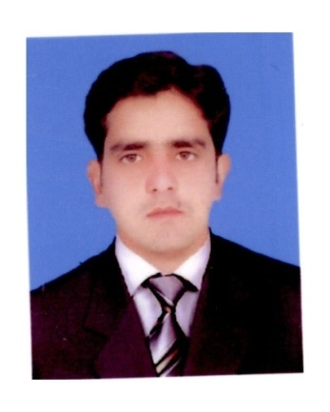
Muhammad Ibrahim
E mail: qibrahim92@gmail.com
CEL : 0301-5103568
Whatsapp: +92-330-5491258

Name: MUHAMMED IBRAHIM

Nationality: PAKISTAN
Passport No: BE1027631
Religion: Muslim

Educational Qualification: MASTERS IN ENGLISH LITRATURE (Con)
Languages Known: Full command over English & Urdu
This is how I think
To be part of a dynamic organization that is growing, expanding and enhancing in every sphere of business line. Thus playing an active role as a role model to make marvelous in the company and facing new challenges.

This is how I am skilled
(With working experience in Saudi Aramco)
- MS EXCEL
- MS WORD
- Inpage Urdu software
- POWER POINT
- SAP Planning and Procurement
- Typing speed 65 WPM

This is how I act
- Good Team Player
- Time Conscious
- Responsible
- Quick Response

This is how I work Currently

Copy Writer Translator/ Subtitling at MCOM Advertising Agency Islamabad
From April 2015 to 2018

TNI (Pvt) Ltd Advertising Agency I-8/3 Islamabad from 2018 to 2019.as a Translators/Subtitling translation different Audio and videos.

Freelancing since 2019 to till now, expert in translation from English to Urdu, Pushto,

Skills in Banking Sector:

Urdu and English Translation and proofreading at competitive and commercial level fair in copy writing Banking sector experience in UBL, Mobilink Microfinance Bank , SME BANK
Banking working focus on Annual reports, Product broachers etc.

Major Clients
- UBL
- Mobilink Microfinance Bank
- Civil Aviation Authority
- Trading Corporation of Pakistan
- Printing Corporation of Pakistan
- KPK Government
- Ministry of Religious Affairs
- CDA
- Pakistan Post
- PM House
- Pakistan Railways
- OGDCL
- Pakistan Broadcasting Corporation
- PESCO
- IESCO
- NHA
- Comsats
- HEC
- National Testing Service

This was how I worked in the Past

Experience in KSA (From14 February 2008 to 2015

Gas Development Drilling Department
UDHAILIYAH
DIVISION#1, West Admin Building: 1020, Udhailiyah KSA..

Major responsibilities are as below:-
- Schedule Meetings
- Processing all the administrative work for the rig employees as per company policy including Office purchases.
- Attending telephone calls and response.
- Also response through emails
- Processing the Rig Evaluation Reports, issuing Temporary Access to the visitors inside Aramco Office and on the Rig, following up on training plan, tracking all IT equipment on all exploration rig.
- Preparing Weekly Highlights and Monthly Reports
- Tools and Bits monthly audit
- Looking after of all computers/printers/fax machines/photocopiers/ tools and equipments/scanners and taking immediate action in case of any problem. Keeping record and checking of flight to northern rigs regarding passengers and seats availabilities.

Reference:

Usman Farid, Superintendent Onshore Division -IV
Phone: +966 3 862-8067 Mobile: +966 554501185
EMAIL: usman.farid.1@aramco.com

PERSONAL INFORMATION:
- Father’s Name : Abdul Razzaq Qureshi
- Date of Birth : 2nd January, 1984
- Passport No : BE1027631
- Marital Status : Married
- Domicile : Islamabad
- Nationality : Pakistani
ACADEMIC QUALIFICATION:

Degree/ Certificate | Year | Board
M.A English | 2008 | University of Sargodha
B.A | 2006 | University of Punjab
Intermediate | 2004 | B.I.S.E .Rawalpindi
Matriculation | 2000 | B.I.S.E. Abbottabad

