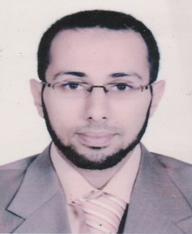
MUHAMMAD FAWZY HARRAS

German-Arabic Translator/Reviewer

English-Arabic Translator/Reviewer

)+20 (1119176222 m.fawzy.harras@gmail.com
)+201 (002039791 mfm.harras@yahoo.com

PROFILE

More than ten years in the field of professional German-Arabic/English-Arabic Translation.
Maintaining a continuous level of competence and development.
Seeking a challenging post where my background education, training, experience and skills can be applied, increase my experience in practical life, and put me in the road for constructive comfortable future.
`

EDUCATION

- Bachelor of Language, Department of German Language and Literature, Languages &Translation Faculty, AL-Azhar University

{Graduation year 2003 (Grade very good with honors degree)}
- Primary & secondary school – AL-Azhar School

{Graduation year 1999 (Grade 91.5%)}

EXPERIENCE

Company 1 Senior Translator/Reviewer from German and English into Arabic
January 2006 in "Arability Limited"
April 2017
Tasks and responsibilities:
- Project Manager
- Reviewer
- Translator

• Translating/Reviewing all kinds of materials including but not limited to:
- Hardware material like printers, Safety devices, coffee machine, heating devices, cookware, etc
(KBA, Bosch, Dräger, Eltex, Muller Martini, Xerox, Duravit, Berker, HSM, KERN, MKN, Kermi, Severin).
- Medical material: manuals for medical equipments, pamphlets of many drugs and Patient information leaflets (Asklepios, Veroval, Cochlear ltd., Mayo clinic, Curea medical, Waldner Laboreinrichtungen, Andoverhealthcare).
- Website Localization: (Wikipedia, Wanzl, Premium Medgate Germany, Karlstorz).
- Automotive material (Volvo, Scania).

- Providing training for junior translators on CAT tools.

Company 2 Part time German Instructor in "ATA" Arabic Training Academy 2010-2011 (10th of Ramadan)

Company 3 Part time German Instructor in "Edu. Master Training Center"
March 2007 (Nasr city)
October 2008

CAT-TOOLS & COMPUTER SKILLS

- SDL Trados (2007, 2014, 2015)
- Across 6.3
- Memsource
- MemoQ (2015)
- Translation Workspace
- SDL Passolo (2011)
- Adobe Acrobat 8.0 Professional
- Windows XP, 10
- Microsoft office 2016
- Internet
`

Personal Information
- Date of Birth: 01-08-1981
- Place of Birth: Cairo - Egypt
- Nationality: Egyptian
- Marital Status: Married
- Military Status: Completed
- Currant Address: 10th of Ramadan City

