Maryam Faal  Linguist, Technical Translator,  Proofreader, Subtitle, Voice over talent,  Project manger, Marketing manager | 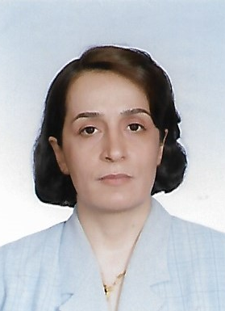

Profile
Experienced and driven linguist, technical translator, project manager, marketing manager with an impressive background of managing and coordinating international projects. Worked as language expert, project coordinator and manager with worldly well-known companies and institutes.
Working Experiences
- Marketing manager and medical terminologist at Medling s r o, Liberec, CR
March 2013 - 2019
- University Teacher, Tehran University, Faculty of Foreign Languages;
Aug. 2012 - Feb. 2013
- Senior linguist at Computer Research Centre of Islamic Sciences, Tehran, Iran
June 2011- Aug. 2012
- Translator and correspondent at Russian News Agency Ria Novosty, Moscow, Russia
April 2010-Feb. 2011
- Technology transfer project manager, technical translator, interpreter (English, Russian Persian), proofreader, Technology Cooperation Office of Iran, in Russia and Iran
May 1998- March 2010
- Freelance Linguist and translator. Working as a language expert, team and project coordinator, linguist, translator, proofreader, subtitler, etc. with well-known companies and institutes,
April 2013- present

Education & Trainings
- Ph.D in philology, People’s Friendship University of Russia, Moscow, Russia
May 2010
-Specialised in Comparative, Historical and Typological Linguistics
- MA in philology, People’s Friendship University of Russia, Moscow, Russia
June 2007
- BA in Russian language, Tehran University, Tehran, Iran
Jan. 2001
- English Language, University of Oxford, Delegacy of Local Examination, SIMIN Institute, Tehran, Iran
Nov. 1997
- Language Engineering, advanced level, UNDL Foundation, Geneva, Switzerland
July, 2014
- Terminology Management, (ECQA), Cologne University of Applied Sciences, Germany
Sept. 2011
Skills
Computer:
MS Office: Word, Excel, Power Point, Outlook, Microsoft publisher;
Adobe Acrobat;
CAT Tools: SDL Trados, MemoQ, Matecat, TB, TWS;
Subtitle: Subtitle Editor, .srt;
Languages:
Persian (Farsi): native
English, Russian: advanced
Czech: beginner
German, Dari, Tajik, Arabic: working experience

