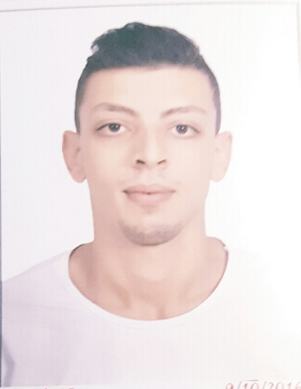
Mossad Ibrahim Mousa Elgnayni
Address : Egypt, Cairo, Nasser City
mobile : (002-01021129817)
Email : mosaadibraheem@gmail.com
Date of Birth : 12/8/1992
Military statues : postponed

Objective
- Seeking a challenging career with a progressive organization that provides an opportunity to capitalize my skills & abilities.
Education and Qualifications

- 2016 Graduated from Tanta University - English Department - Faculty of Arts.

Personal Skills
- Accurate: Careful, precise and free from error.
- Creative thinking and excellent problem solving.
- Ability to work under pressure
- Dynamic quick learner and teacher: The ability to learn new tools.
- Hardworking: Planning and prioritizing with energy and industrious.
- Team player: Ability to work in a team.
- Very good communication and presentation skills.
- Making good presentation of my ideas, and work for long time with high efficiency.

Languages

- Arabic (Mother Tongue).
- English (fluent).

skills

- Good knowledge of computer, software and hardware and a knowledge of Microsoft office word and power point.
- General knowledge about (SDL Trados program).

Experience

- 1/2013 – 3/2014 Training in Trans Arabia Certified Company as a professional translator.
- 7/2013 – 12/2014 Working in Trans Arabia Certified Company as a professional translator.
- 7/2014 – 12/2015 Working in Trans Arabia Certified Company as a professional translator.
Courses and Qualifications

- 2016 ILTS English Course at British Council
- 2016 English Course at British Council
- ICDL Self Study.

Interests and Activities

- Drawing.
- Traveling.
- Sports: football and swimming.

References

Available on request

