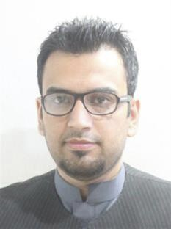

Mohsin Afaq Khan
MBA- Finance
Pro Translator/Web Developer

Native Languages:
Urdu, Pashto
Contact Details
Mobile: +92-0333-9039858
Personal E-mail: mohsinafaqkhan@gmail.com
Skrill: mohsinafaqkhan@gmail.com
Home Address: Hayatabad Phase 3, Sector L-2, Street No # 11, House No # 215, Peshawar, Pakistan

Personal Summary: D.O.B: 09-05-1988
A hardworking, pro-active fast translator with an upbeat and positive attitude. As an efficient and organized person, I am punctual and reliable, results driven and able to complete the projects effectively within a stipulated time, whilst having an active and dynamic approach to work and getting things done efficiently.
Would like to work as a translator for a successful and ambitious company that offers great opportunities for career development and progression.
Working Languages
- Translate English to Urdu or vice versa.
- Translate English to Pashto or vice versa.
Work Experience:

Freelance Translator (Jun 2015- Present)

- Translation & proofreading of general documents, advertising, media documents for many clients and agencies in US, Europe & UK.
- Translating Technical, Medical, Science, Cultural and business texts to Pashto and Urdu for clients and agencies.

Key Skills and Competencies

- Familiar with software translation tool (SDL Trados 2015).
- Expert and experienced in using MS Word 2016, MS Excel 2016 & Outlook.
- Experienced in WordPress and have developed a website for health and fitness (www.healthandfitnessforall.info ).
- Excellent communication skills.
- Experienced in Adobe Illustrator & well aware of affiliate marketing.

Rates per Word/Hour

- English to Pashto (Pushto) & vice versa - Standard rate: 0.05 to 0.06 USD or GBP per word / 12 to 14 USD or GBP per hour.
- English to Urdu & vice versa - Standard rate: 0.03 to 0.06 USD or GBP per word / 10 to 11 USD or GBP per hour.

AREAS OF EXPERTISE

- Translation
- Proofreading
- Interpreting
- Transcription
- WordPress
- Themes Customization
- Web Development

Educational Qualifications:

- MBA (Finance) from (IMStudies), University of Peshawar 3.3/4.0 GPA (2008-2010)
- B.Com from University of Peshawar, Pakistan 1st Division (2006-2008)
- FSc from Army Public School & College, Nowshera 1st Division (2004-2006)
- Matric (10th Standard) Army Public School & College, Nowshera 1st Division (2002-2004)

