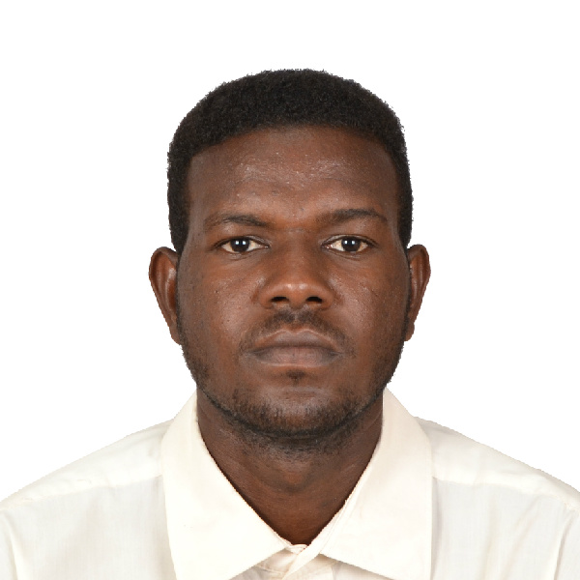
Curriculum vitae

Personal Informations: iINFORMATIONS

- Name: Mohammed Abdalla Yousif Zaroug
- Date of birth: 1/1/1994
- Gender: male
- Place of birth: Omdurman - Sudan
- Nationality: Sudanese
- Marital status: Single
- Address: Omdurman Salha transportation st
- Cell phone: +249925428635
- Email: wadzarog@gmail.com
Educational background:

- Diploma Degree in Translation – English Discussion
Institute from 2/6/2013 up to 4/7/2015.
- Human Resource planning and development ـــ National Institute of Labor Economic – Delhi, India 6/2019 to 8/2019
Work experience:

- Three-year experience as a General Translator at Babel Translation
Center from 7 July 2015 up to August 2018.
- One years of experience as a volunteer (part time job) at the Sudanese Organization of Awareness and Development from 1/2018 up to 1/2019.
Courses:

- Tricky American English -California University Irvine – online Coursera.
Skills:

- MS Excel – advance
- MS word – advance
- MS PowerPoint – intermediate
Languages:

- Arabic – Native speaker
- English – fluent
Social media:

- LinkedIn: @https://www.linkedin.com/in/mohammed-zaroug-95b
- Twitter: @@h ttps://twitter.com/mohammedzaroug1
- Facebook: @@https://web.facebook.com/mohamed.abedallahyuse
Hobbies:

- Watching football matches
- Travelling
- Reading English Literature

*Supporting Documents Available Upon Request*
Diploma holder review of tender drawings BOQ items/scope Prepare BOQ's, costing, pricing & rate analysis of direct & indirect cost for the BOQ items. consultants & contractors scheduled & certify the quantity of work for preparing running bills & final bills construction site engineering

