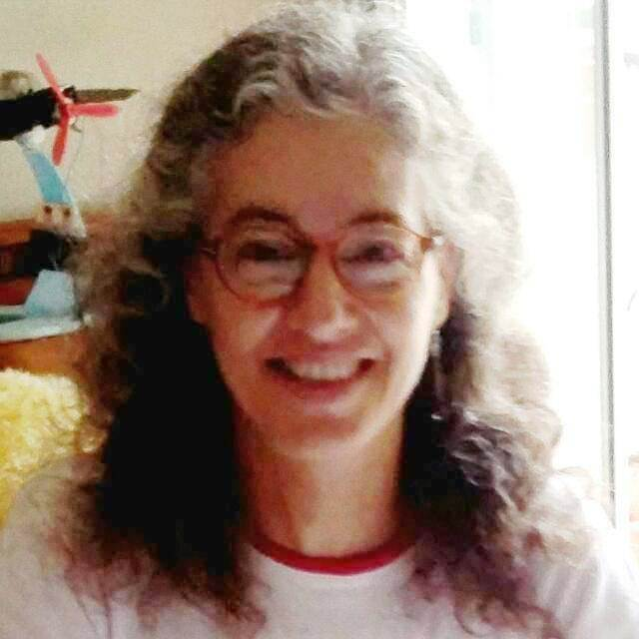
Mireia Goula Iglesias
Date and place of birth: 09/08/1964, Barcelona (Spain)
Living in 08027 Barcelona
mireiagoula@gmail.com

www.linkedin.com/in/mireia-goula
​http://www.proz.com/translator/2936819

WORK EXPERIENCE

From 2006: Freelance translator, Barcelona (Spain):

Work languages: from French or English to Spanish or Catalan.
Specialization:

- Technology (user manuals, technical specifications and rates, international tenders, electricity, robotics, energy measurement - electrical and electronic meter, metering and power transformers - quality standards...).
- Medicine (equipments, devices...),
- Art, Culture and Tourism (exhibition catalogues, restaurant menus, touristic webs and brochures...).
- Marketing & Commercial (business plans, rates, product catalogues and e-commerce webs...).

Some clients:

- A French public entity related to tourism
- A German company manufacturing meters and wanting to sell them in China.
- A French company manufacturing electric wheelchairs and wanting to sell them in Spain.
- A Spanish architects office who presented bids for French tenders.

1991-2003: Work experience as an Executive Secretary and first translations, Barcelona:

- TREND COMMUNICATIONS, S.L.: British multinational (plot generators and analyzers for telecommunications).

- BIC IBERIA, S.A.: French multinational (lighters, pens and razors).

- SANOFI BEAUTÉ, S.A.: French multinational (cosmetics and perfumes).

- ITRON SPAIN, S.L.U.: US multinational (electricity, gas and water meters and voltage and power transformers).

1989-1990: First work experiences as a Secretary in Paris (France).

1986-1988: Work as an au pair, Paris (France)
EDUCATION

LANGUAGES

French:

* Certificat d’Aptitud de l'Idioma Francès, Escola Oficial d'Idiomes (official foreign languages school), Barcelona, 1996.
* Native level (I lived in France for 5 years).
* Diplôme Supérieur d'Études Françaises Modernes, school Alliance Française, Paris, 1987.
* Certificat Pratique de Français Commercial et Économique of Chamber of Commerce and Industry of Paris, 1987.

English:

* Course "Technical Translation from English into Spanish"; International House, Barcelona, 2006.
* First Certificate in English of Universidad de Cambridge, the British Institute, Barcelona, 1993.
* English intensive course in the United Kingdom (Oxford), Oxford Tutorials, 1991.

Catalan:

* Certificat C de Català of Junta Permanent de Català (certified by local government Generalitat de Catalunya), 1996.

INFORMATION TECHNOLOGIES
* TAO: Trados Studio 2021, Memsource
* Subtitle Edit
* Word 2007
* Microsoft Office Specialist in Excel 2013 (Microsoft official course, 2017)
* Powerpoint (course, 1994)
* Adobe Indesign (official course done in 2021)
* Adobe Acrobat Reader

INTERNATIONAL TRADE AND SECRETARIAL

* Course Technician of International Trade, officially certified by Generalitat de Catalunya (local administration), at school “Idiomes, S.L.”, 1998.

* B.T.S. de Bureautique et Secrétariat (professional training), at private school Langues et Affaires (Levallois, Paris), 1988-1990.

GENERAL STUDIES

C.O.U. (high school diploma), Liceo Español de París (France), 1988.

