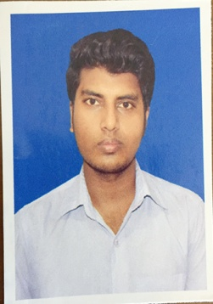
Curriculum Vitae
OF

MD Osman Gani
E-mail: mdosmangani184@gmail.com
Contact No: 01863189229

Educational Qualification:

Bachelor of Architecture
University : Dhaka University OF Engineering And Technology
Department : Bachelor of Architecture
Result : Running Student ( 3rd year)
Duration : 5 Years

Diploma Engineering
Institute : Feni Polytechnic Institute
Group : Architecture and Interior Design Technology
Result/GPA : GPA-3.57 Out of 4
Passing Year : 2016
Board : Bangladesh Technical Education Board

Secondary School Certificate (SSC)
Institute : Ramgoti B B K Pilot Model High School
Group : Science
Result/GPA : GPA-4.75 Out of 5
Passing Year : 2011
Board : Comilla

Personal Quality:
Good team player, Believe in self-dignity, Well communication skill, Enthusiastic, Sincere and Egger to learn.

Computer Literacy:
Operating Systems : Windows 98/2000/XP/7/8.1/10
Software Application : Autocad, 3Ds Max, Sketchup, Photoshop,
MS Office
Internet Access Capability : Browsing, E-mail Checking, Chatting.

Language proficiency:
English : Fluent in speaking and writing.
Bengali : Mother tongue.

Hobbies:
Traveling, Reading, Playing Cricket, Football etc.

Biography:
Name : MD Osman Gani
Father’s Name : Khurshid Alam
Mother’s Name : Mokader necca
Date of Birth : 15/06/1995
Nationality : Bangladeshi By Birth
Mailing Address : Vill: Borokheri, P.O: Ramgotir hat, P.S: Ramgoti
Dist: Lakshmipur
Permanent Address : Vill: Borokheri P.O: Ramgotir hat , P.S: Ramgoti
Dist: Lakshmipur
Religion : Islam
Marital Status : Unmarried

Reference:

1. MR. Johirul Islam
Lecturer
of the Department of Architecture
Dhaka University Of Engineering And Technology(DUET)

I hereby assure you that all the information supplied in this curriculum vitae is true, and if any inconsistency found then you have right to reject it.

Signature

