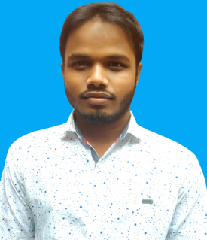
CURRICULAM VITA

Name: Md. Murshidul Islam
A Student of the University of Rajshahi
Email: mdmurshidulislam894@gmail.com
Contact Number: +8801933197780
Career Objective
Looking for a challenging Job where I will have the scope to utilize my potentiality, Adaptability skill to do something creative and I will be able to enhance my Knowledge.
Experiences
More than one year experiences on Translation, Data Entry and Transcription work as a freelancer.
I am working at TranslationDirectory.Com, Proz.com, TranslatorsCafe.com, Fiverr and People Per Hour freelancing sites.

Personal Qualitative Attributes
- Energetic, dynamic and proactive.
- Able to do work under pressure with due care.
- Motivated to adjust in various work environments quickly.
- Strong communication, interpersonal and leadership skills
Language Skill
- Excellent capability over English and Bengali on reading, writing, listening and speaking.
Computer Proficiency
I have an excellent knowledge & experience on the following programs:
Microsoft Word, Excel, Access, Power Point, Translation and Internet Browsing.
Educational Q
Educational Qualification
Bachelor of Science ( Running 2017 to 2020) Department : Chemistry Year: 4th Institution : University Of Rajshahi Website: http://www.ru.ac.bd
Higher Secondary Certificate (H.S.C) Group: Science Institution: Khan Shaheb Kamar Uddin College Board: Jessore Passing year: 2016 GPA: 4.67 (out of five)
Secondary School Certificate (S.S.C) Group: Science Institute: Amadi Jaigirmahal Takim Uddin High School Board: Jessore Passing year: 2014 GPA: 5.00 (out of five)
Personal Details
Father’s name : Md. Aiub Ali Sardar Mother’s name : Mst: Afiron Begum Present Address: Village: Dharampur , Post: Motihar , Thana: Motihar , District: Rajshahi Permanent Address :Village: Ghugrakati ,Post: Ghugrakati ,Thana: koyra ,District: Khulna Date of birth: 15-Octobar-1998 Religion : Islam Nationality : Bangladeshi Marital Status: Unmarried

Interested On
Reading Newspaper, Learning and Traveling.

I hereby declare that the above statements are true to the best of my knowledge.

Date:01/05/ 2020 Murshidul
Signature

