* Bengali
* English
* Chinese

Language

Work experience

Objectives

*I able to provide a perfect assignment of every subject related to my work and promote the services offered by the authorities.*

Interpreters-With; Miss Cao Yong Mei (曹永梅) -Xinjiang, Shihezi, China-832000 (Nov 05, 2016- Feb 02, 2019)

• Attended training programs to improve professional knowledge and interpretation skills.

• Provided oral translations and interpretations for new students and successfully maintaining pace with native speakers to deliver real-time comprehension.

• Provided cultural input to speakers to help parties who did not speak similar languages communicate with and understand one another.

Education

Skills

* High level of initiative.
* Excellent content writing skill.
* Well develop translation skill.
* Strong sense of urgency and self-confident.
* Proofreading and editing.
* Student monitoring.
* Academic advisement.

MBBS (2015-Present)

Shihezi Medical University

Shihezi, Xinjiang-832000

Contact

* Address: Siddhirganj, Narayanganj, Dhaka.
* Email: [*imtiaznazmul760@gmail.com*](mailto:imtiaznazmul760@gmail.com)
* Phone: +8801609294603
* Present address: Siddhirganj, Narayanganj, Dhaka.
* Skype: live:.cid.c574dac23666eb3e

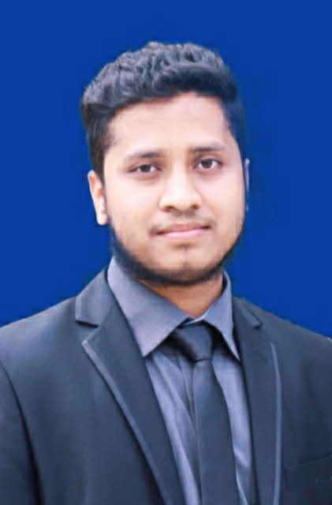

MD IMTIAZ M NAZMUL HASAN