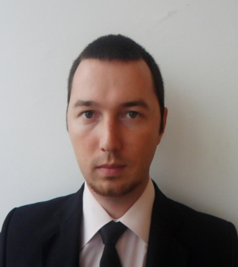
Curriculum Vitae

Name and Surname: Mr. Maxim Baranov
Residential Address: 350089, Chekistov Avenue 26/5, Krasnodar, Krasnodar
Region, Russian Federation
Tel: 007 861 2619894 (home)
+7 9283348090 (cell phone)
E-mail: maxim.07_07@yahoo.com
Nationality: Russian
Sex: Male
Date of Birth: 07.07.1986
Marital Status: married, daughter
Education:
1993 – 2003 Secondary School (Krasnodar, Russian Federation)
2003 – 2008 Kuban State University (Krasnodar, Russian Federation),
Translator of German, English Languages/Philologist

Work Experience:
2008, 10th November nowadays “Advent Translation” translator English, German
2009-2010, 08th April till 12th March ZAO “ETK”Company/ ABB AG interpreter/translator German
2011 17th March till 02th June. Parts Purchase specialist OOO “Agro-Construction Technologies”
2012-2013 23th August till 08th February. ZAO "Rosengineering" Work on the Olympic facilities
in Krasnaya Polyana (Sochi) with austrian engineers from contractor companies Rombergbau GmbH and Doppelmayr GmbH. The simultaneous and consecutive interpretation on building sites, meetings, translation of meeting minutes.
2013 16.08 – 16.10 “TTP Marines” work on the military warship Vikramaditja in the sea. Oral translation, teaching of Indian crew.
2013-2014 28.10 – 14.02 Nussli AG Work with swiss and german partners on the Olympic facilities. Organization of workers accommodation, administrative work, translation of contracts, application forms, rental of cars.
I translate also notarial documents.
Language Skills: German - Advanced
English – Upper-intermediate
Spanish - Beginner
PC Skills: Advanced user (MS Office, All Finger Typing, Internet, Photoshop, TRADOS, SDFX, 1C, Frontpage, Dreamviewer, Outlook. Advanced user of office equipments.

References: Tonkick Evgeniy ZAO "Rosengineering" +79284556606 project manager
Paul Winkler Rhombergbau GmbH +436648314898 engineer
Objective: Interpreter \translator\manager or other
Remuneration: negotiated

