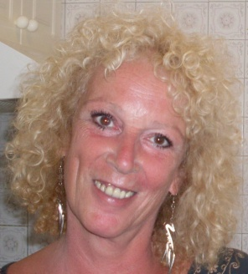

CURRICULUM VITAE

Personal details

Name: Mary Jane Cruz (nee Nicholson)
Address: Calle Bence, 9, Las Adelfas, 38400 Puerto de la Cruz, Tenerife, Islas Canarias.
Date of birth: 18/8/54
Nationality: British
ID Number: X0153049 - F
Contact numbers: 922 374037 / 922 388622 / 659324718
Email address: booksmania@hotmail.com

Education

1958 – 1968 Eothen School for Girls, Caterham, Surrey, England.
1969 -1971 Equivalent of High School, obtained through a Correspondence course with the University of London (due to the fact my family emigrated from Great Britain before I could finish my studies).

Additional studies

- French course in an Academy in Madrid
- German Course in La Universidad Popular, Puerto de la Cruz, Tenerife
- Course on revising and editing technical English with La Universitat Rovira i Virgili, Facultat de Lletres, Tarragona, Spain
- I am currently studying to become a certified translator.

Other details of interest

Among my recent work, the following are the most relevant:
- From the year 2006 until 2007 I was working with rdnattural (www.rdnattural.es) translating their web page, their encyclopaedia, their forum and everything related to their products, treatments etc.
- Since the year 2005 I have been working with the translation agency www.net-traducciones.com, translating documents and web pages for La Caixa Bank on a regular monthly basis, as well as other documents for Iberia, Vodafone, travel agencies, beauty products etc.
- I translated ¡Qué Bueno es Gran Canaria 2004! ( A diner’s guide)
- I translated ¡Qué Bueno es Gran Canaria 2005! ( A diner’s guide)
- I worked with the archaeological museum in La Gomera
- I contributed to the “Walking Map” and “Tenerife by Car” by Dr. Moll
- From the year 2004 until 2006 I worked with the Cultural Association of Pinolere, La Orotava, Tenerife, handling all their correspondence related to the basketry competitions held yearly.
- From the year 2002 until 2006 I dealt with all the correspondence between a British Businessman and his legal representatives here in Tenerife.
- I have been translating deeds, medical reports, court papers, newspaper articles etc. for many years.

Professional experience

- From 1987 until 1998 I gave private classes at home, worked for the Parents-teachers’ Association in the Toscal Longuera School, and taught in the Colegio Trinity, Carretera del Botánico, Puerto de la Cruz.
- In 1998 I worked for the foundation in Loro Parque, Puerto de la Cruz, Tenerife.
- From 1998 until 2002 I was employed as manageress of a bookshop.
- In 2002 I bought the bookshop and built up a successful business. I sold the business in 2009 to become a full-time translator.
- I continue to work on a regular basis with Net-Translations, as well as several others.
- This summer I have been working in an English summer school, C&T English Experience, Puerto de la Cruz, Tenerife as a monitor/teacher.
- I helped to create and translate the web page for www.QRme.es, part of Multiprint, Puerto de la Cruz,
- I am presently translating the web page for www.canarianmobility.com

I can supply references when required.

