Marouane Boukbal

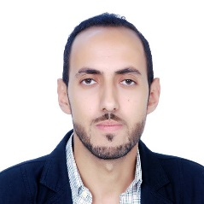
2 bis rte de fes ,sefrou
31000, Morocco
+212620524080
Marouane.boukbal@gmail.com

Energetic , motivated ,results-oriented person eager to bring strong skills to a growing company in need of a multipurpose support. Excellent organization , communication and relationship-building skills.

PERSONAL INFORMATION

Born February 21, 1985 in Sefrou (Morocco)
Citizenship: Moroccan
Marital status: married, 1 kid

WORK HISTORY

09. 2005 - present Men , Rabat
French and Arabic teacher
- Conduct small group and individual classroom activities with students based on differentiated learning.
- Participate in ongoing staff training sessions.
- Employ assessment tools and proactive strategies to improve instruction methods.

06.2014 – 05.2015 Trustedtranslations
English Arabic translator
- Proficient translation
- Patience in face of difficult texts and fileds

10. 2008 – 04. 2011 Fesweb , Fes
Web developper Freelancer, remotely
- Design websites and outline schedules
- Manage web projects.
- Carry out quality assurance tests to discover errors and optimize usability.
06.2012 – 09.2014 website
Web administrator
- Created 4 website in this duration
- Self designed and developed

06.2014 – 05.2015 nimesite , nime , france
Online support
- Proficient troubleshooter
- Maintain patience in face of difficults customer situations
- Provide support and problem resolution for customers

EDUCATION

09.2000 – 6.2003 Royal academy high school , Meknes
student
- Got my high school degree in 2003

09.2003 – 06.2005 CFI , tanger
Teacher formation
- Got my teaching certification in Cfi , tanger

09.2005 – 06.2008 University dhar elmahraz , fes
Student
- Bachelor degree in English

Qualifications

language Arabic , English and French

Programing language PHP , Html , css , mysql

skills computer skills , electronic , hacking and security , translation

