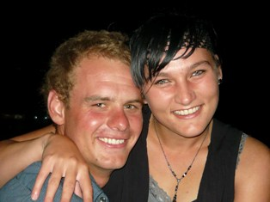CURRICULUM VITAE

OF

MARLENE BURGER

PERONAL INFORMATION

SURNAME: Venter Burger

FIRST NAMES: Marlene

GENDER: Female

DATE OF BIRTH: 1988-10-21

PASSPORT NUMBER: 466440138

NATIONALITY: South African

POSTAL ADDRESS: Po Box 30
Dewetsdorp
9940

TELL (CELL): +27072 185 4116
(HOME): 051 583 1998

EMAIL: marlizeburger21@gmail.com

RESIDENTIAL ADDRESS: Eureka
Wepener
9944

MARITAL STATUS: Married

HEALTH: Excellent

CRIMINAL RECORD: None

DRIVERS LICENSE: code 10

RELIGION: Christianity

LANGUAGES: English
Afrikaans

INTERESTS: Farming
Reading
Hiking
Writing
Tennis
People
Swimming
Fishing
Gardening

EDUCATION

HIGH SCHOOL ATTENDED: Zastron High school

HIGHEST GRADE: 12

SUBJECTS: Afrikaans first language HG
English second language HG
Biology SG
Geography HG
Woodwork SG
Economics SG

REFRENCES: K.Fouche
+27082 708 1644
F.A. Nel:
+27083 338 6159
OTHER

Golden Hour
BAA Paramedics Course
HPCSA registered

REFRENCES: Mr. Mabesa
+2773 180 8779

WORK EXPERIENCE

Wepener Printers
Graphic design

REFRENCES: A. Greef
+2751 583 1148

(Volunteer ambulance work)
Farming with husband- J.M Burger
+2772 595 4066

