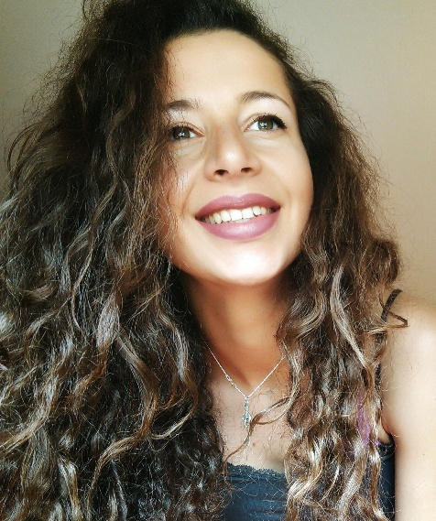  Mariana Slavova  CONTACT  Address:  Sofia, g.k. Yavorov 49  Phone:  +35989 854 1181  Email:  mariana.slavova93@gmail.com  LANGUAGES  German – C1  English – C1 |  | WORK EXPERIENCE  05/2016 - 02/2017  Sixty K Plc - International Contacts Centres, Plovdiv  Position  - Research specialist, eBay project  Responsibilities:  - Data Research and Validation  10/2017 – 12/2019  Telus International Europe  Responsibilities:  - German and English Customer Service Advisor for a financial  - Project  2018 – Present  Freelance translator (German – Bulgarian / Bulgarian – German)  02/2020 – Present  Teacher of German language at Park School Britanica, Sofia  EDUCATION  2012 – 2016  Bachelor's Degree of Pedagogy of Music Teaching, Plovdiv University  2015 - 2019  Bachelor's Degree of Applied Linguistics in German and English, Plovdiv University  04/2017 – 09/2017  ERASMUS+ International Mobility at the Faculty of Linguistics  TU Dresden, Germany  2008 - 2012  Secondary Language School "Hristo Botev", Kardzhali  ADDITIONAL SKILLS  MS Office  Fluent in German and English  Driving license cat. B

