 | Maria Dolores Rosas A.
14-6-2010
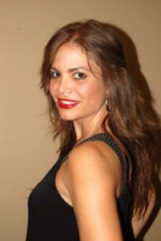 | Garcia Morales #808  Navojoa, Sonora, Mexico  52-642-421-3772  mdra75@hotmail.com

translator
aCADEMICS
SAINT SCHOLASTICA ACADEMY
MAY 1991 / HIGH SCHOOL
CANON CITY, COLORADO, USA

PIMA COMMUNITY COLLEGE
MAY 2002 / ASSOCIATES DEGREE IN BUSINESS ADMINISTRATION
TUCSON, ARIZONA, USA
experiencE
ENGLISH TEACHER | INSTITUTO TECNOLOGICO DE SONORA
SEPTEMBER 1999 – JUNE 2001
NAVOJOA, SONORA, MEXICO

TRANSLATOR | REPRODUCTIVE HEALTH CENTER
JUNE-AUGUST 2007
TUCSON , ARIZONA, USA

EXPERT IN BUSNESS ENGLISH AND MEDICAL TRANSCRIPTS

