Ms. Maria CHIGRINA  Borodinskaya 45-68  398026 Lipetsk, RUSSIA  +7 904 295 70 82  +33 6 42 52 29 02  @ chigrina.maria@gmail.com | 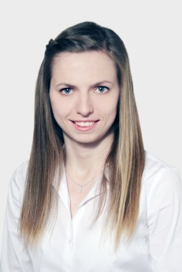 | LANGUAGES  Russian: Mother Tongue  French: Near-Native  English: Fluent

EDUCATION
2011-2013 | Stendhal University of Grenoble, France  Specialized Multilingual Translation Masters Degree (Russian/French/English)
2010-2011 | Lipetsk State Teacher Training University, Russia  Diploma in Translation (Russian/French)
2005-2011 | Lipetsk State Teacher Training University, Russia  Diploma in French & English Teaching

PROFESSIONAL EXPERIENCE
August 2014  – present | Technicis (France, Paris), TransPerfect (UK, London)  Translation Agencies  Freelance Translator & Revisor
May 2013  – May 2014 | World Intellectual Property Organization (Geneva, Switzerland)  Translation Service of the Patent Cooperation Treaty  Terminology & Translation Fellow (English/French-Russian)
November 2012  – March 2013 | Domaine Patrick Miolane (Saint-Aubin, France)  Wine production  Drafting of a Bilingual Glossary on Wine-Making
October 2012  – August 2013 | ATLAS (Grenoble, France)  Foreign Applied Languages Translators’ Association  Translator (French-Russian), Reviser, Project Manager
June 2012  – August 2012 | SARL « Zakouski » (Gap, France)  Translation Agency  Translation Intern (French-Russian)
September 2012  – May 2013 | Stendhal University of Grenoble (France)  Slavic Languages Department  Russian Teacher
May 2011  - August 2011 | « Otrada Gen » Ltd. (Lipetsk, Russia)  Pig farming development  Import Manager, Translator (French/English-Russian)
October 2009  – April 2010 | Académie de Rouen (Le Havre, France)  Lycée François Ier; Collège Raoul Dufy; Collège Irène Joliot-Curie  Russian Teaching Assistant
September 2008  – June 2010 | Groupe « Sucres & Denrées » (Lipetsk, Russia)  SA « Sucrerie de Dobrinsky »  Interpreter/Translator (French-Russian)
TECHNICAL SKILLS
Translation: SDL Trados Workbench, TagEditor, WinAlign, Passolo, SDLX
Terminology: SDL MultiTerm, TermoStat, AntConc, Lingo
Operating Systems: Windows XP, 7, 8; Mac OS
Office Applications: Word 2010, Excel, Google Docs, OpenOffice
Email: Microsoft Outlook, Gmail
Presentation: Power Point

