CURRICULUM VITAE
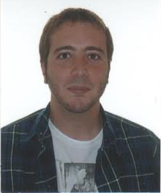
Name Marcos Martínez
Adress C/ Merineros
Número: 22 – Piso: 2º C
C.P: 42001 (Soria)

Phone NO. 0034 650081148 / 0034 975230841
Birth Place Soria, SPAIN
Birth Date 17/05/1988
Nationality Spanish
Marital Status Single

- EDUCATION

- BA in Translation and Interpreting by Universidad de Valladolid, Spain (2007-2012)
- Certified Translator by the Spanish Department of Foreign Affairs
- Master in Audiovisual Translation (Dubbing and Subtitling)

- OTHER QUALIFICATION AND SKILLS

- Languages

- Spanish (Native)
- English
- German

- Software
○ Microsoft Office Word, Excell and Powerpoint.
○ SDL TRADOS
○ SDL Multiterm
- SDL Certification Status
○ Subtitle Workshop
○ Aegisub
○ VisualSubSync
○ FAB

- EXPERIENCE

○ Freelance Translator (2012-2014)
- English/German>Spanish Translator of agricultural machinery specialized texts for MC STONE CRUSHER SL (2012-2014)
- Certified Translation assignments: English<->Spanish. (2012-2014)
- English, German and Spanish private teacher. (2010-2014)

- INTERESTS: Reading, films, music, computers and sport.

