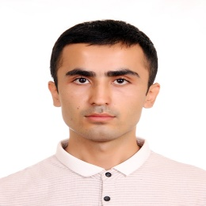
Khasanov Maksadbek
Address
131/35, Str. Buyuk Ipak Yuli, Mirzo Ulugbek District, Tashkent, 10052, Uzbekistan
Personal Details
Date of Birth: 13.12.1993
Mobile: +998998905013
Email: knownmax@gmail.ru

CAREER OBJECTIVE
Looking for challenging position in an environment, where my professional attitude drive towards success enabling me to contribute to further growth and development of the organization and myself. Employ my skills and potentials to assist an organization to reach its objectives.
EDUCATION BACKGROUND
№ | Background | Location | Degree | Educational term
1. | Tashkent State Institute of Oriental Studies | Tashkent,Uzbekistan | Korean language and literature | 2012-2017
2. | Hanshin University | Osan city, Republic of Korea | Student exchange programm | 2015-2016
WORK EXPERIENCE
Company Name | “Dream and Wise Solution” LLC (The Representative of Korean trading company “GW International”)
Period | 04/2017- 05/2019
Position | Office Manager
Work Responsibilities | 1.Creation of documents and control over the flow of company documents  2. Translation from and into Korean, English, Russian and Uzbek languages  3. Work with company’s clients and oversees employees  4. Market analysis for materials supply  5. Preparation of international trade contracts

LANGUAGE PROFICIENCY

 | Uzbek | Russian | Korean | English
Speaking | Fluent | Fluent | Fluent | Intermediate
Writing | Fluent | Fluent | Fluent | Intermediate
TRAININGS
Korean Language Proficiency at King Sejong Institute

CERTIFICATES
- TOPIK 5 level
COMPUTER SKILLS
- Microsoft Office (Word, Excel, Power Point)

STRENGTHS
- Completion of the assigned work on time
- Ability to strategically thinking and prioritize

