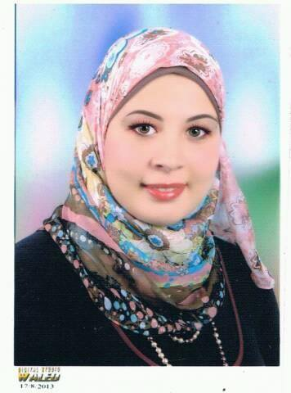
Mai Bakr
Address: Sidi Salem City P.O Box 33743, Kafr Al-Shaikh. Egypt
Mobile No. +0201060073641
Email: maibakr1991@yahoo.com / maibakr1991@gmail.com
ـــــــــــــــــــــــــــــــــــــــــــــــــــــــــــــــــــــــــــــــــــــــــــــــــــــــــــــــــــــــــــــــ
Objective
Seeking Part time or Freelance job related to Translation environment where skills in translation can be utilized.
ـــــــــــــــــــــــــــــــــــــــــــــــــــــــــــــــــــــــــــــــــــــــــــــــــــــــــــــــــــــــــــــ
Qualification
Bachelor Degree in Languages and Translation, Department of Simultaneous Interpretation (English)- Al-Azhar University - Good Grade - Sept 2014.
ـــــــــــــــــــــــــــــــــــــــــــــــــــــــــــــــــــــــــــــــــــــــــــــــــــــــــــــــــــــــــــــــ
Current Job
• English to Arabic-English Freelancer Translator from June 2013 till present.
• Legal Freelancer Translator at Al Hamadan consulting Law Firm - Kingdom of Saudi Arabia - October 2014 till present.
- Freelancer Fashion Copywriter from English to Arabic – April 2015 till present.
ـــــــــــــــــــــــــــــــــــــــــــــــــــــــــــــــــــــــــــــــــــــــــــــــــــــــــــــــــــــــــــــــ
Experience in Translation
- Legal
- Legal Contracts and Agreements.
- Technical Studies.
- Marriage Contracts, Birth Certificates and Graduation Certificates.
- Association Certificates.
- Internal Documents including Brochures, Letters, proposals and E-mails.
- Scientific and Technical Book about Desalination.
3- Fashion copywriting and creative Translation
- Dior, Molton Brown, L’Occitane and Benefit Brand
- Press Releases & Interviews.
- Websites and Portals Translation.
- Products Description.
4- Human Resources
- Management and Administration Articles.
- CVs.
ـــــــــــــــــــــــــــــــــــــــــــــــــــــــــــــــــــــــــــــــــــــــــــــــــــــــــــــــــــــــــــــــ
Courses
- Workshop in Human Resources Management at US Embassy, March 8-10, 2015.
- Course in Advanced Office 2010, November 2014.
- Course in Human Development (Interview and C.V), March 2010.
ـــــــــــــــــــــــــــــــــــــــــــــــــــــــــــــــــــــــــــــــــــــــــــــــــــــــــــــ
Computer Skills: Proficient with Microsoft Office Programs.
Personal Skills:
- Able to deliver tasks on time.
- Able to handle urgent tasks.
- Dealing with translation involving different texts formats (diagrams, charts, pictures etc.)
- Hard worker under stress.
- Self-Planning and Time Management.
Languages
Mother tongue Arabic
Other Languages
• English: Excellent written & spoken
• French: Good written & very good spoken.

