CURRICULUM VITAE
Mahmoud Ahmed Oraby Mahmoud
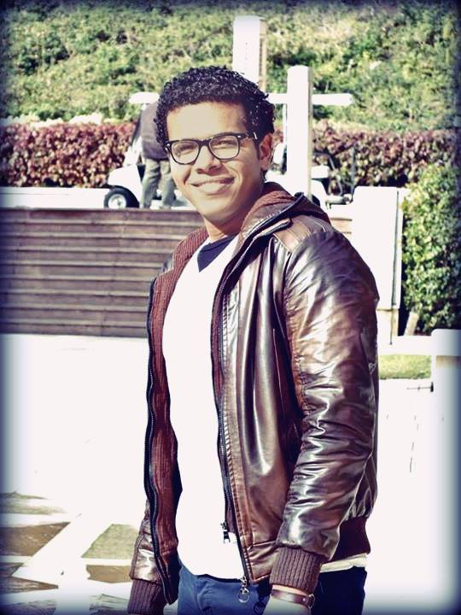 Contact Number: 0020 1148906021
Email: oraby7652@hotmail.com
Personal Data
Nationality: Egyptian
Gender: Male
Date of Birth: 11-05-1994
Place of Birth: Cairo
Marital Status: Single
Objective
To work around art.
Education

Second year student at the facility of arts, the department of English Language & Literature,
Ain Shams University, 2013-2016
first year Grade Good, second year Good, third year Good.-
-Three Writing Workshops at ASU English Department Certificates, Creative writing by Dr. Sherine Khalil author of Moon Shadow.
Ideal student of both the department and the facility year 2013-2014 -
Work Experience
A salesperson at a supermarket for a month
A waiter for a month at copyshop (Abraj el Abasya)
Worked as a freelance legal translator for a year at copyshop (Abraj el Abasya)
Games freelance translator
Translator –subtitles- at Iqraa Islamic T.V. channel for a year.
Wrote a video game script, still in progress.
Skills
Languages
- Arabic: Native speaker
- English: Excellent (spoken, read, & written)

Computer Skills
- MS Windows
- MS Word
- MS PowerPoint
- Internet
- Video editing
- Photoshop
Personal Skills
- Sociable communicator
- fluent English speaker
- Creative, Dynamic and hard-working
- Reliable and dependable in meeting objectives and deadlines
- a writer (Arabic/English short stories, free verse, prose)
- passionate comics reader

