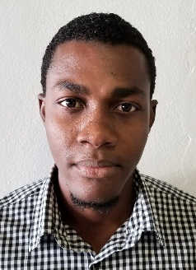

Apart 6, building Raylin 12th Street, Arroyo Hondo Arriba, Santiago, Dominican Republic
Email: luckensonlouischarles@gmail.com
Cell: 809-434-7871

Personal Information:

Passport: PV4188780
Nationality: Haitian
Date of birth: 25/04/1992

Goal:

I want to work for a company or in an environment that requires good human relationship and good strategies on selling products and attending clients, where I can use my language skills, be available for full or part time, meet wonderful people and keep helping the company reach its goals.

Education:

- 2013 -2016 Faculty of International Relations (FADRI), Diplomatic science
(Folder closed)
- 2012 -2013, Graduated in office automation (Microsoft Office Software )

Experiences:
.
July 2017 - March 20182
Company : Global contact Media : ( Marketing agent)

March 2018 - August 2018
Company : B&S Solutions : (Marketing agent)

Spoken and writing Idioms:

English, French and Spanish
Reference : Xiomara Ultega

