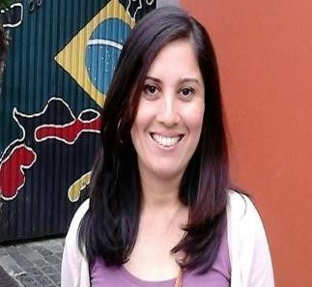

,

CONTACT

CURITIBA – PR - Brazil
Zip code: 80730-350
Mobile:+55 31 8240-8383
e-mail: lirio09@gmail.com

ABOUT ME

Let me introduce myself. After many years living abroad, in USA, back to Brazil I created my activity as freelance translator and ESL Teacher. I believe that translation build bridges between languages, cultures, and countries. I work as a translator and Language Teacher since 2009.
SKILLS
Fluent English– Certificated by proficiency Test.
CAT tool translations (Smartcat,MemoQ, Wordfast,..)
LILIANE AGUIRRE
English – Portuguese(BR) translations since 2009 -BRAZIL

PORTUGUESE FREELANCE TRANSLATOR/INTERPRETER and PROOFREADER

Freelance Translator and Language Teacher
2021 to now - Freelance consultant for relocation and immigration.
2011 to now – Freelance Interpreter / English Language consulting for Brazilian companies for presentations abroad..

EXPERIENCE

From 2017 to now - Freedom School online – Brazil
Online English Teacher ( ESL / Portuguese for foreigners)
All ages and levels, preparation courses to applying for proficiency tests. (TOEIC, TOEFL, IELTS,…).

From 2017 to 2019 – Freedom School – Jaiba- MG
Co-founder and Pedagogical director – Responsible for Implementing the learning process at this Language school, hiring and training teachers and teaching. All ages and levels.

From 2015 to 2017 – VW Idiomas – Belo Horizonte - MG
Pedagogical Coordinator – Responsible for hiring and training teachers for this Language School. Work under a huge branch of schools of a major brand in Brazil, implement methodology based on communication and NLP.

From 2012 to 2015-SAVASSI Idiomas –
Belo Horizonte-MG
English Teacher- ESL teacher for all levels and all ages. Work under a huge branch of schools of a major brand in Brazil, implement methodology based on communication and NLP.

LANGUAGE COURSES

- In-company English Teacher: small groups and individual.
- Portuguese teacher for foreigners.

TRANSLATIONS/INTERPRETER SERVICES

- consecutive and simultaneous Brazilian Portuguese-English/English-Portuguese interpretation;
- Translations Services Portuguese-English/English-Portuguese:
- localization
- Web sites
- Documents
- Contracts
- Political sciences
- International exchange and cooperation
- Social and Human sciences
- Environment
- Language Courses: Portuguese for Foreigners and ESL ( English as a Second Language)

EDUCATION

- Bachelor of Linguistics and Language Sciences – UEMS
- Master’s degree in International Relations – PUC MG - BRAZIL
- Bachelor’s Degree in international Relations – PUC MG - BRAZIL
- Associate Degree in Liberal Arts – PBCC – FL – USA

