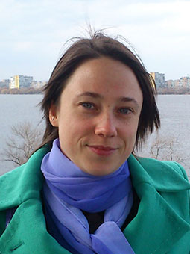 | OLESIA KOSTENIUK  Ukraine, Dnipropetrovsk  GMT+2(3)  Full-time freelance TRANSLATOR  - From English  - Into Russian (native)  - Into Ukrainian (native)  Contact details:  - Tel.: +38 (066) 212-27-97 (MTS Ukraine)  - E-mail: lesia.kosteniuk@gmail.com  - Skype: lesia.kosteniuk  - ICQ: 219056416
Fields of Expertise:  - Chemistry  - Law  Every new translation is one more opportunity to develop my professional skills. | Chemistry  With a Bachelor degree in this field, I can look deeply into both chemical and allied subjects, such as instrumental analysis, laboratory equipment, chemical engineering, pharmacy, biochemistry, petroleum chemistry, etc.  My experience of translation in this area is over half a year. Over 120,000 words have been translated so far.  Law  I have over one-year translation experience in the given field. Over 70,000 words have been translated so far.
Professional Experience  If you are interested in my portfolio, please, go here:  http://www.translatorscafe.com/cafe/file/?id=87087 | I have been working as a freelance translator since November 2012.  For this time, I translated:  (chemistry and software)  - Operating manuals for analytical instruments  - Analytical software reference  - Flyers and other marketing materials  (law)  - Contracts, agreements  - Personal documentation (diplomas, work books, certificates, etc.)  - Powers of attorney, statements, invoices  - Articles of association and other business documentation of companies  (other)  - EU regulation  - Design guide and other technical documentation  - etc.  Besides, I have built on the following skills:  - Efficient searching on the Internet  - Working with CAT-tools
Education:  - Translation (English)  - Natural science (Chemistry)  Such combination enables me to do accurate translation in context using correct and easy-to-understand language. | 2011—2013  Translation (English language), Specialist degree  Kharkiv University of Humanities "People's Ukrainian Academy"  Department of Postgraduate Education  1999—2004  Chemistry and basics of computer science, Bachelor degree  (Specialization — Physical chemistry)  Dnipropetrovsk National University  Department of Chemistry
Working Software  I am ready to master new tools that will help to improve my translation quality and reduce your costs. | In addition to standard applications, I work with:  - САТ tools:  - SDL Trados 2011  - MemoQ  - AutoCAD (basic level) — translation of drawings  - Adobe Photoshop (professional level) — image processing
Translation Capacity | My output depends on the subject and complexity of a source text. Normally, it is 1300–1700 words per day.
Payment Methods | You may choose any payment method convenient for you:  - PayPal  - Internet wallets (WebMoney, Yandex.Money, QIWI)  - Bank transfer
Cooperation with Me  For detailed information, please contact me in any convenient way. | For you, cooperation with me means that:  - You receive the text that is translated as though it was initially written in Russian/Ukrainian  - We may negotiate the performance of your order at the weekend  - You can easily assess the quality of my work — I can translate up to 300 words for free

