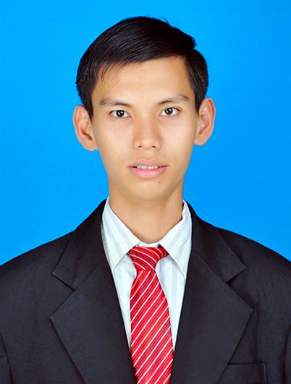CURICULUM VITAE
LENGPOR NGUON
Address : Tropeang Chhuok Village, Mesor Chrey Commune,
Stung Trung District, Kampong Cham Province, Cambodia.
Tel : +85570 37 27 17 / +85588 95 47 947
E-mail : nguonlengpor@gmail.com

PERSONAL BACKGROUND
Sex : Male
Nationality : Cambodian
Marital Status : Single
Date of Birth : November 30, 1992
Place of Birth : Tropeang Chhuok Village, Mesor Chrey Commune,
Stung Trung District, Kampong Cham Province, Cambodia.

EDUCATION BACKGROUND
2014 - 2017 : Successfully graduated a Master Degree of Business Administration
2011 - 2014 : Successfully graduated a Bachelor Degree of English for Communication at Western University.
2008 - 2011 : Graduated High School at Mesor Chrey High School

TRAINING COURSE
Oct - Dec, 2012 : Completed Leadership Course
July 27-29, 2009 : Participated in a seminar, YOUNG ADULTS’ PROBLEMS.

COMPUTER SKILL
Mar - June, 2011 : Completed Microsoft Word, Excel and Power Point

LANGUAGES
Khmer : Mother tongue (Excellent)
English : Second Language (Excellent)

INTEREST
Reading books, watching English movies, listening to the radio and playing sports.

EXPERIENCE
2008 - now : Has been teaching English at SMART KIDS International School
Duties : - Teaching English both full-time and part-time
- Administration Assistance
- Responsible for translation work

REFERENCES
Mr. KUNTHEA HAM : Professor at WESTERN UNIVERSITY
Tel: +85517 56 56 27

