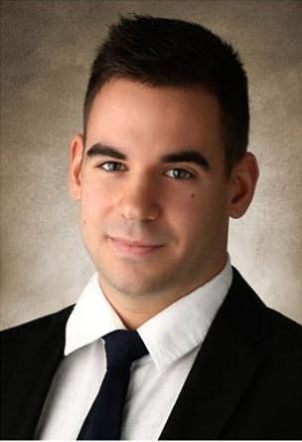
László Tamás Mészáros
Nationality: Ungarn/Hungarian
Date of birth: 10. October 1993
Adress: 9000, Aalborg Boulevarden 27. 1/8,
Denmark
Cell phone: +4551727748
E-mail: laszlomeszaros93@gmail.com
Studies:

2014- Aalborg University – Economics and Business Administration, Aalborg, Denmark

2011-2013 Lincoln High School, Portland, Oregon- USA

2008-2014 Hunfalvy János Economics and Business Vocational School, Budapest, Ungarn

2000-2008 Herman Ottó Elementary and Middle School, Budapest, Ungarn

Language skills:
Hungarian - Fluently
English – Fluently
German - Advanced
Danish – basic(undrestanding, writing)
Spanish - basic(understanding, writing)

Work experience:
- translation (2010-)
- kitchen and cleaning(2013-2014)
- administrative student jobs(2012-2013)
- sales management(2013)
Other qualifications:
Handle Microsoft Office well (Word, Excel, Power Point and Access)
Hobbies:
cooking, basketball, handball, swimming, running, reading, working in the garden.

