Resume

Kseniia Koverska

HELLO  My name is Kseniya. I’m freelance translator, transcriber and reviewer. I live and work in Kamianske, Ukraine. | 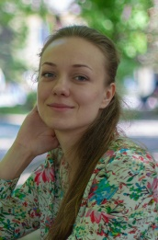  CONTACTS  kseniya.koverskaya@gmail.com  +380984017761

Education  2009-2013, Alfred Nobel University, Dnipro, Ukraine  Qualification – bachelor of science in linguistics, translator  2016, Prometheus platform, Software Testing Basics course  2017, INIT-school, Dnipro, Ukraine, Web-Development Basics course | Skills  - Computer: Word, Excel, PowerPoint, Internet, Adobe Reader, Adobe Acrobat, HTML, CSS, Word Press  - Languages: English – advanced, German – basic, Ukrainian, Russian – native  - Effective work with deadlines  - Self-motivated, solution-oriented, flexible, imaginative, multi-tasking, proactive, positive-thinking, investigative skills

Experience

2020 – freelance translator at GetYourGide
Translation of tour texts from English into Russian

2017-2020 – transcriber and transcription reviewer at Lionbridge

2010-2017 – remote translator, freelancer
Cooperation with translation agencies Logos, Translation Service, Bridge, SM Group

Translation of user guides, operating manuals, account statements, safety requirements, production requirements, tender documentation, quality certificates, contracts, statutes, documents etc.
2014-2016 – work on translation and proofreading of the book “21st Century Radionics” by Nick Franks
Translation of medical documents (assessments, CT and MRI findings).

