CURRICULUM VITAE
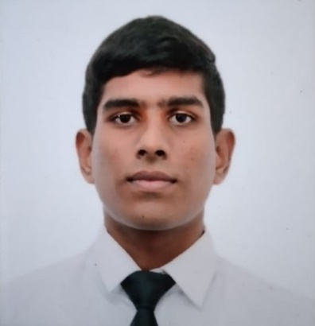
Heshana Liyanaarachchi
19/B/26,
Rukmalgama Housing Scheme,
Kottawa.
E-Mail : heshanaliyanaarachchi98@gmail.com
Contact No: 0779323447 / 0711010036

1. Personal Details.
- Name in Full : Mr. Liyana Arachchige KAvindu Heshana Liyanaarachchi
- Name with initials : L A Heshana Liyanaarachchi
- Address : 19/B/26, Rukmalgama Housing Scheme, Kottawa.
- Date of Birth : 15th September 1998
- Civi Status : Single
- Nationality : Sri Lankan (Sinhalese)
- Religion : Buddhist
- Gender : Male
- School Attended : Nalanda College, Colombo 10.

2.Academic Qualifications.
G.C.E Advanced Level Commerce Stream (Sinhala Medium) 2017.
- Economics : C
- Accounting : C
- Business Studies : C
- General English : S

G.C.E Ordinary Level (Sinhala Medium) 2014.
- Buddhism : A
- Sinhala Language & Literature : B
- English : B
- Science & Technology : C
- Mathematics : C
- History : A
- Commerce : B
- Drama : A
- Health Science : A

- Following a Higher National Diploma in Quantity surveying at ICBT campus Bambalapitiya.

I’m a freelancer, Sinhalese native speaker from Sri lanka. I can translate English to Sinhalese vice versa. I’m interested in this opportunity. I have translated texts, documentaries, reports, informed consents and web sites in various fields. Currently im a university student who is following a quantity surveying degree in International College of Information & Technology (ICBT) campus. I’m good at subtitle translations and all the other construction related translations etc.

3. Extra-Curricular Activities.

- The Sergeant of the Eastern Cadet Band of Nalanda College in 2017.
- Participated the all island annual competition of national cadet corps training center Rantambe in 2013, 2014, 2015 & 2017.
- Followed the Non Commission Officers Course of National Cadet Corps Training center Rantambe in 2015 & 2017.
- Participated the Guard of Honor of Sri Lanka Police in 2015.
- Runners up the Haritha Swara band competition of St. Johns college Nugegoda in 2017.
- Participated to the Sandhawani band show of the St. Paul’s college Milagiriya in 2017.
- Participated the last parade of the inter house sportsmeet of Nalanda college in 2012 &2013 as a cadet.
- Awarded to the English Language of the annual price giving of Triple A Academy in 2014.
- Won the 2nd place of the scout and cub scout swimming meet free style 100m category event in 2012.
- Followed the emergency first aid and basic life support course of the Nalanda College of Anaesthesiologists of Sri Lanka in 2014.

I hereby certify that the information given above is true and accurate to the best of my knowledge.

Date: 14/01/2020

