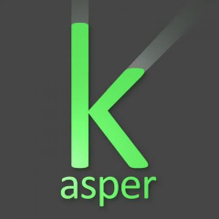
KACPER
SZOKA
Freelance Translator

INFO  EMAIL:  kasperisgreen@gmail.com  WEBSITE:  kaspergreen.pl | PROFILE  Experienced Polish/English translator able to work in multiple environments with vast scientific, technical and cultural knowledge.  EMPLOYMENT HISTORY  Quality Assurance Technician, Globalme  February 2020 – July 2020  Member of Quality Assurance Team responsible for quality assurance of manual transcription output.  Self-employed, Kasper Green  Nov 2018 – Jan 2020  Working freelance for multiple clients providing translation, interpretation and transcription service. Translating documents, manuals and subtitling videos.  EXPERIENCE  - creating subtitles and closed captions  - transcribing audio and video content in Polish and English  - responsible for correcting errors made by speech recognition software  - knowledge of various types of software used in transcription provided by clients  - ability to use proper transcription formatting  - experience in translating large quantities of audiovisual content from Polish to English and vice versa
EDUCATION

2009 – 2012
University of Wrocław, BS in Mathematics

