JYOTIRMOY BHATTACHARYA
V.K.Colliery
P.O. – Khandra
P.S. – Andal , Dist – Burdwan, Pin – 713363 (W.B.)
MOBILE NUMBER : 8250069894
E-Mail: jyotirmoyukh2018@gmail.com
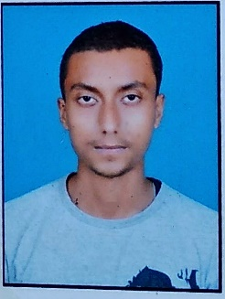
CAREER OBJECTIVE | To pursue a career as an active player in the growth and development of the organization which provides a challenging work environment and allows me to grow both professionally and personally. I am very hardworking and also passionate to my work.

EXPERIENCE | - Worked as Business Development Employee at GOIGI, Durgapur.
 | - Working as Freelance Translator since 2015.
 | - Worked as Medical Translator at Glocal Healthcare (2015-16).
 | - Worked as Translator at Indigram Skill and Knowledge Initiatives Pvt. Ltd (2016-17).
 | - Worked as a Technical Translator at Skills Mantra Edutech Pvt.ltd (2017-18)

QUALIFICATION | Board/university | Year of passing | Percentage
Secondary | W.B.B.S.E. | 2008 | 66 %
Higher Secondary | W.B.C.H.S.E | 2010 | 62 %
Honours in Economics | The University of Burdwan | 2013 | 49 %

PROFESSIONAL SKILL  Computer Proficiency | - MS WORD, EXCELL, POWER POINT.

PERSONAL DETAILS  Father’s Name  Mother’s Name  Marital Status | Gopinath Bhattacharya  Sabita Bhattacharya  Unmarried
Date of Birth | 7th March, 1993
Sex  Nationality | Male  Indian
Language known | English, Hindi, Bengali.
Hobbies :- | Listening Music, Drawing, Travelling, Reading.

Declaration :- | I do hereby declare that the information furnished above by me is correct to the best of my knowledge

