Juan Danza

Public Translator

EXPERIENCE

**Translator and Proofreader | Haymillian (Present)**

Subtitle Translator and CC Proofreader.

Translator | Under NDA (Present)

Translator for an American AI Technology Company

Freelance Translation | Streaver

Translation of internal commercial documents EN>ES.

EDUCATION

REFERENCES

**Cristina Chiusano**

Chair of English Faculty - University of Montevideo [cristinachiusano@gmail.com](mailto:cristinachiusano@gmail.com)

LANGUAGES

English-Spanish

Learning German and Chinese

A2 and HSK 2

**Foteini Kotsi**

Project Manager at Haymillian

[fkotsi@haymillian.com](mailto:fkotsi@haymillian.com)

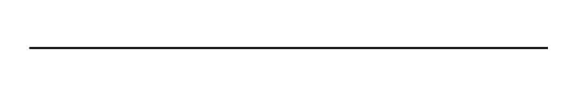



**PERSONAL STATEMENT**

Public Translator and soon­to-be Literary Translator. I'm interested in AVT and localization. I pride myself in the quality of my job. Moreover, I believe the key for a successful translation is constant communication between members of the translation team and the client.

Bachelor’s Degree in Public Translation - University of Montevideo   
March 2019 — December 2022.

Bachelor’s Degree in Literary Translator - University of Montevideo

March 2019 — Present.

COURSES  
Minimaster en localizacion de videojuegos - Traduversia (Specialization in Videogame Translation) 2022  
  
(Specialization in Localization and Transcreation) 2022  
  
Correccion, estilo y variaciones de la lengua española -  
Universitat Autonoma de Barcelona. 2021  
(Specialization in Editing and Style in Spanish)  
  
English Language and Culture Diploma University of Montevideo. 2021

**Exploring Linguistics -** University of Essex. 2020

**Translation Software**

SDL Trados Studio 2021

SubtitleEdit

OCR Abbyy Finereader

MS Office Suite



**Contact Info**

+598 99412106

[Juan.danza.rov@gmail.com](mailto:Juan.danza.rov@gmail.com)  
  
 Montevideo, Uruguay

