Curriculum vitae
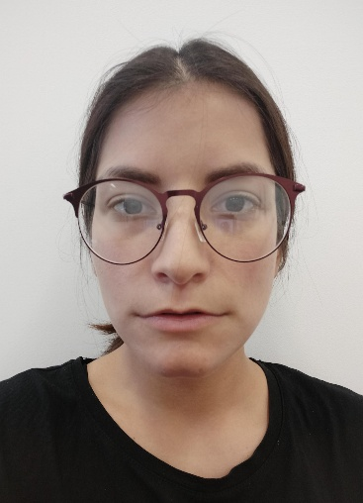
Personal data: Popović Jovana
Date of birth: 06. 11. 1995.
Place of birth: Podgorica
Home adress: Hercegovačka 97, 81000 Podgorica, Montenegro
E-mail adress: popovic.jovana23@outlook.com
Mobile phone number: +38268/513-203
________________________________________________________________
Education:

Sep 2018-present University of Montenegro
- Academy of fine arts, Department of Painting– Bachelor studies
- Philological faculty, Specialization in Teaching
Sep 2014- July 2018
University of Montenegro
- Philological faculty, English language and literature – (BA degree)

Sep 2010-2014
- Grammar school „Slobodan Skerovic“, Podgorica, Montenegro
Sep 2002-2010
- Elementary school „Savo Pejanovic“, Podgorica, Montenegro

Work experience:
Jan – Oct 2019
- Centre for Investigative Journalism of Montenegro (CIN-CG). Internship where worked on translating articles, projects and documents. Generated project ideas and workd on implementation of projects.
July 2019
- Reporters Without Borders, Paris. Internship: translation and transcription of materials concerning media freedom of Eastern Europe.

- Translation (SRB- ENG, ENG-SRB) for ecological research, Nikšić. July 2018
Civic activism:
NGO ADP-ZID: as a volunteer, participating in number of activities: organizing and leading international camps, promoting human rights and ecological activities.
- Leader or co-lider of several international camps organized in Ulcinj, Kolasin, Zabljak (2013-2016)
- ''Let's do it Montenegro'' a part of a global civic ecological movement (2016) – project coordinator
- ''Celebration of the Drin day'' –an educational camp about Drin ecosystem (2017)

Languages:
- English: advanced
- Italian: intermediate
- Spanish: beginner
- French: beginner

Skills:
- Excellent comunication and organisational skills
- Team player and leadership skills
- Creative thinking and writing skills
- Microsoft office, Photoshop, Internet

