T R A N S L A T O R

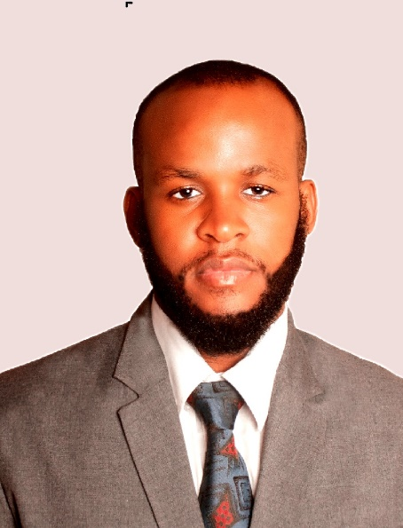
JEAN MAX BEAULIERE
J A C K S O N

GET IN CONTACT

Mobile: +1-809-315-1698
jeanmaxbeauliere@gmail.com
23, Calle Domingo Emilio Garcia, Reparto Imperial, Santiago de los Caballeros, Dominican Republic
PERSONAL PROFILE

A translator with a 5 years
experience into the language
services field. Responsible, able to work as a team, able to manage
time, Leadership, Project
management, Accounting and Design, Provide good interpersonal collaboration

AREAS OF EXPERTISE
Microsoft OFFICE ( Word, Power Point, Excel)
Corel Draw, ADOBE Photoshop memoQ
memSource Wordbee
SDL Trados Studio 2019-2021 Subtitle Edit
Cyracom (XTM) Quickbooks SAP
Passolo
Studio One Pro

OTHER SKILLS
Can analyze the context of a written text for a better
translation and help the reader to better understand.
Haitian Creole (Native Language)
English (Intermediate - read, write and spoken)
French (fluent - read, write and spoken)
Spanish (Intermediate - read, write and spoken)
WORK EXPERIENCE
june 2016 - My first job was with CS to help to translate some words in a Machine Learning Project. Since I translate more than 1 million words for Creole Solutions and still working for them.
September 2016 - My second job was to help U.S. Marines with their medical duty in Haiti back in 2016. I had to translate for both the marines and the citizens receiving medical assistance.
March 2018 - Started with Creole Translations and I had translated more than 120,000 words for them.
September 2019 - I was hired by Vocalink Global, a company in which I translated about 100,000 words worth of documents ranging from education workbooks, lifestyle, Government, Legal, medical insurance documentation, poetical and literature notes, and the current situation of COVID-19 topics for schools and businesses.
December 2019 - I also worked with Wordlights Translation staff as a contractor to deliver a strong translation and transcription(subtitling) for a documentary on many aspects of Haiti's
living standards. I also helped the team to translate more than 40,000 words also worked with them on health-related documents (COVID-19).
January 2020 – I worked with Clear Words Translations with the translation of nearly 30,000 words. I worked on many documents ranging from COVID-related subjects to school programs and even legal documents for people speaking only Haitian Creole. And now, I am also working as a proofreader. I think I am ready to take more of these and have a future with your team.
February 2020 - Hired by Protranslating, I worked before as a translator and I translated more than 100,000 for them and now I am also working as a proofreader.

EDUCATION HISTORY

BRIGHAM YOUNG UNIVERSITY IDAHO ONLINE – TEACH ENGLISH AS A FOREIGN LANGUAGE (TEFL)

2021 - 2023: During this period of time, I studied many terms related to English language which helped me to build skills with my English, in order to speak, write, and read. I had to write and deliver essay on my daily routine. In fact, I am grateful to take these classes to better understand this field as a system, I have a strong English understanding.

BRIGHAM YOUNG UNIVERSITY IDAHO PATHWAY CONNECT - ENGLISH AND GENERAL SKILLS CERTIFICATE

May 2014 – May 2015: I spent one year attending this online class while learning general skills for a better understanding of the world and English writing to better fit what I was preparing to do the following year (Entering BYU-I online university). The ENG 101 course helped me to build a strong relationship. I learned how to have strong writings and this helped me through my experience as a translator.

