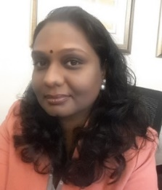
JAYA RAJAN
Blogger
Malayalam, English

Dubai, UAE
+971 55 978 7861
jayashankar04@gmail.com

- Area of expertise
- Transcription
- Translation
  - English to Malayalam
  - Malayalam to English
- Proof Reading
- Content writing
- Editing
- I am a native Malayalam speaker, currently working as a Business Analyst with a reputed airlines.
- Regular blogger at
  - http://indrachapam.blogspot.ae/
- Regular Writer and Admin Panel member of Facebook group നല്ലെഴുത്ത്‌ - nallezhuth
  - https://www.facebook.com/groups/nallezhuth/?ref=group_header
- As one of the editors of a popular Malayalam online magazine, I spend considerable time editing and proof reading Malayalam short stories and poems
  - http://www.nallezhuth.com/2017/11/2017.html

