Curriculum Vitae

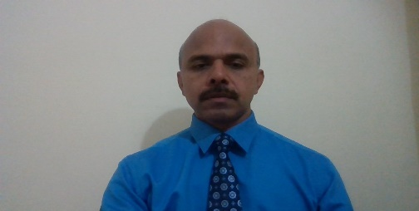
Name : James Sebastian
Address : Flat 4/F4, Kamath Plaza,
St. Inez, Miramar, Panaji
403001
Objective: To seek a challenging position where I can apply my diverse skills & knowledge, in my area of work to make good contribution towards the growth of organization as well as mine.
Personal Details:
DOB : 31st January April 1970
Age/Sex : 50 years/male
Marital Status : Married
Languages known : Can speak & read English and Malayalam
Nationality : Indian
Religion : Christian
Contact No. : 9995849216
Educational Qualification: SSC
Skills:
- Expert in Microsoft office
- English Typing – 60 words per minute
- Malayalam typing – 40 words per minute
- English short hand – 100 words per minute
- Languages: Fluent in English and Malayalam
- Can work efficiently under pressure.
- Understands and appreciates the importance of a job well done.
- Self – motivated, hard working
Educational Qualification:
Examination | Board / University | Year of passing | % secured
SSC | SSC Board | 1987 | 66%
Additional Qualification:
- Passed lower grades of English typewriting and short hand in 1987
- Attended 66 hour course in Finance for Non-Finance Executives held in 2003 at Bangalore
Working Experience:
- From 1989-2005 worked as accountant (since 1997 as chief accountant and purchase manager) for the Indian wing of an International Organization known as Jehovah’s Witnesses first located in Pune and then in Bangalore
- From 2006-2012 worked as a translator plus translator trainer for English to Malayalam translation in Bangalore for the same organization
- From 2013-2019 August, worked as a translator, translator trainer, audio coach, voice actor, voice actor trainer, technical supervisor, HR, and Malayalam website supervisor for jw.org site from Kochi, Kerala
- Since 1989, working also as Instructor and Lecturer to large gatherings of thousands and handling classroom discussions in English and Malayalam on a variety of subjects such as science, history, religion, social and family life mainly on every weekend
- Since 1997, worked periodically as an on stage translator from English to Malayalam and Malayalam to English
- Since 1994-2005, worked part-time on software programming

I hereby declare that all the information given above is true and fair. Looking forward to work with you and have the joy of educating people and be satisfied with the work that I love.
Thanking you,
(James Sebastian)

