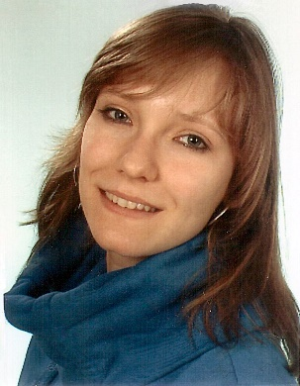
CURRICULUM VITAE INGA SCHOEL

Last Name Schoel

First Name Inga

Born at 07.07.1994

Born in Berlin-Mitte

Living in 15344 Strausberg, Walkmühlenstr. 25

_____________________________________________________________________________________

Parents Father Gunnar Schoel
Professor at HTW-Berlin

Mother Christine Schoel
Doctors Assistant

_____________________________________________________________________________________

Education

2001 - 2007 Primary School „Hegermühlen-Grundschule“ in Strausberg

2007 - 2013 Secondary School „Theodor Fontane-Gymnasiums“ in Strausberg with Allgemeine Hochschulreife (Abitur)

2013 - 2016 Dual study at Fachhochschule für Sport und Management
And the fitness studio Joynes Sportclub in Birkenwerder

2016 - 2020 Sports therapist at the Physiotherapy Diana Rohner in Birkenwerder

2017 - 2020 Master study Integrative Sport-,Bewegungs- und Gesundheitswissenschaft at Universität Potsdam

_____________________________________________________________________________________

Honors and Awards

2009 Internship of two weeks in the Hotel and Restaurant „Seegasthof“ in Strausberg

2009 - 2013 Trainer assistant in the Schulsportverein „Theodor Fontane-Gymnasiums“ for Gymnastics and Volleyball

2012 Trainer licence C for Sports

2015 Trainer licence for Rehabilitation and Prevention

2016 - 2019 Acquisition of further licenses in the health sports sector, such as
Drums Alive, Nordic Walking Instructor, Relaxing methods,
Singing bowl therapy, neck exercises

_____________________________________________________________________________________

Extracurricular Experience
2002 - 2010 Guitar lessons in Musikschule Märkisch-Oderland

2008 - 2010 Gymnastics in „KSC Strausberg e.V.“

2005 - 2013 Member in a Volleyballteam

2014 - 2016 Gymnastics in „TSV 1997 Oranienburg e.V.“

2014 - 2016 Volleyballteam in „Bonsai Sachsenhausen“

2017 - 2020 Circus Cabuwazi at Tempelhofer Feld Berlin

2017 - 2020 Gymnastics in Unisportverein Potsdam

2018 - 2020 Urban Sports Member

