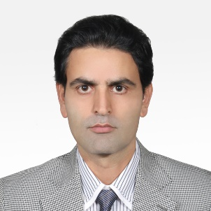
Dear Sir,
My name is Hossein Farahani. I was born in 1974 in Iran. I live in Tehran. I have a BA degree in English Translation. I have translated more than 30 books on cinema, theater, media, politics, history, etc., from English into Persian. I have also translated hundreds articles on different academic fields from English into Persian and vice versa.
Best Regards
Hossein Farahani

