Hassan Hamdi  Mohamed Ahmed  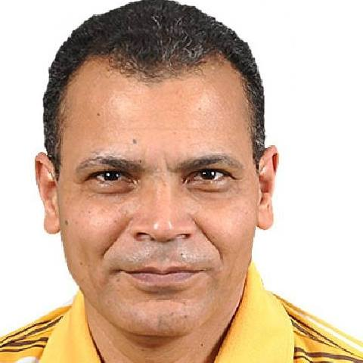 |  | Residence: Dubai, UAE  Visa: Transferrable  Nationality: Egyptian  Cell: (00971) 0561838437/0559361067  hhamdi3000@gmail.com  Face: https://www.facebook.com/Hassan.Hamdi1970  Whatsapp: 009710559361067
PERSONAL | Date of Birth: November 7, 1970  Place of Birth: Nawasa Al Ghait, Aga, Dakahlia  Citizenship: Egyptian  Visa Status: TRANSFERRABLE
OBJECTIVE | Position as a senior translator in a translation companies; to help develop the company I work for and achieve its strategic objectives.
EMPLOYMENT | Freelance Translator  2009 - present  - Translating various materials from English into Arabic & vice versa.  - Translating a series of textbooks for Al Baradei Publishers, Mokattam  - Proofreading various translated books, articles, contracts  Dar Al Kitab Al Arabi-Cairo  2005-2009  Translator & Writer  - Translating books and materials in various fields  - Authorship of 8 books  - Translating 40 books of Mills & Boon series under the Arabic title "Abeer"  - My translated Series "Legends of the Jews" was best seller in Cairo Book Festival 2015
Blue Beach Club, Dahab, South Sinai, Egypt
October 1997-May 1998
Receptionist
- Receiving guests and answering their enquiries,
- Checking guests in & out,
- Communicating with guests in various languages and catering for their needs
- Assumption of a managerial role, when required.
Ministry of Education, Egypt
October 13, 1994 - December 1, 2005

Senior Teacher of English Language, Secondary Stage
- Teaching the English language curricula for students in preparatory and secondary stages
- Preparing mid-year and end-year exams for students
- Taking part in the supervision over examinations

- Taking part in student attainment enhancement courses organized by the schools of the Ministry

EDUCATION | Faculty of Arts, Mansoura University, Mansoura, Dakahlia, Egypt  BSc in English Literature  May 1994  Faculty of Petroleum & Engineering, Suez Canal University, Suez  1989-19990  Two years in the preparatory year then moved to the faculty of Arts, Mansoura University
SKILLS | Language - Fluent in English & Arabic, intermediate in written French, German & Italian  Computer Skills – Operating Systems (Windows all version, Linux) Microsoft Office Package, DTP in general, data mining, Social Media, Graphic Design  Personal Interests – Reading, IT, Sports, Fishing  Publications – 8 books (4 translated from English to Arabic + 2 authorships + 2 co-authorship)
Daily Output: | 2500-4000 words in average  Depends on the complexity and nature of material and clarity of PDF files (in some cases)
Areas of Expertise & Sample works: | International Law:  - The Law of the Sea in our Time II, The United Nations Seabed Committee 1968-1973, Shigeru Oda, A. W. Sijthoff, 1977  - Modern Law of the Sea, Selected Essays, David Anderson, Martinus Nijhoff Publishers, 2008  - Towards the Conceptualization of Maritime Delimitation, Antunes, Nuno Sergio Marques (2002), Durham University  Legal:  - Court Rulings, Defense, Appeal & Cassation notes, Powers of Attorney, Affidavit, Notarial Service  - Birth Certificates, Marriage Certificates, Public Tenders  - PA & DA reports, Expert reports,  - Federal Laws, Cabinet Resolutions  Auditing, Internal Control & ERM:  - Internal Control — Integrated Framework (2013), COSO  - COSO-Based Internal Auditing (2014), COSO  - Enterprise Risk Management — Integrated Framework (2004), COSO  Business & Financials:  - Memoranda of Association, Articles of Association  - QNB several fund prospectuses  - Financial forecasts  - Balance sheets, loss and profits accounts, Income statements, cash flow statements  Literary:  - 40 issue from the famous Mills & Boons series
References: | Waleed Nasef, Dar Al Kitab Al Arabi, Cairo, Tel: 00201144440954, Cell: 00201222150771

