CURRICULUM VITATE
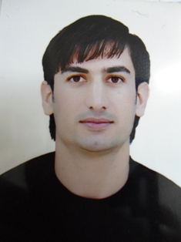
Personal Information:

Name: Halo Bakr Shawkat

Birth date: 18/06/1986

Nationality: Iraqi / Kurdish

Marital status: Married

Address: Iraq –Kurdistan Region-Erbil

Mobile: 00964 7507017269

E-mail: Halo_bakir@yahoo.com

Language Skills:

- Mother Language: Kurdish (Mother Tongue),
- Kurdish: V. Good (Speak, writing and Reading)
- English: V. Good (Speak, Writing and Reading)
- Arabic: V. Good (Speaking, Writing and Reading)
- Turkish: ( Speaking )

EDUACATION:
B.A degree in English Department College of languages, University of Koya Faculty of Humanity and Education (2012)

Computer Skills:
- Windows: Me, XP 2000, XP2003, Vista, Seven
- Microsoft Office: Word, Excel, Outlook, Access
- Internet Explorer, Firefox, and others

Work Experience:

Job Title | Name of Employer | From | To
Translator | GLS company with American Army | 01/07/2009 | 01/10/2010
Camp boss | Marthone Company | 01/07/2012 | 01/10/2012
Safety(HSE) | Kar group for Oil and Gas | 05/10/2012 | 01/06/2013
Admin & Consultant | British education Bureau | 03/06/2013 | Till now

Licenese Driver

- I have license driver from 18/03/2008.

Work SKILLS:

- Good Communication skills with companies,
- Office, Administration, Logistics and Procurement Skills
- Hard working, more that my time and staying for long time.
- Field work, going outside country and city and do the job excellent way.
- Knowledge of procurement and purchasing procedures required.
- Strong communication, analytical and project management skills a must.
- Knowledge of transportation regulations/law desired.
- Experience in international agreements desir

