CURRICULUM VITAE
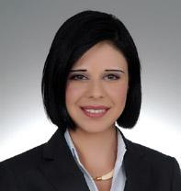
Name and Surname: Gülşah Şengün
Date and Place of Birth: 09 November 1978, Ankara, Turkey
Nationality: Turkish
Educational Background
February 1991- July 1993 Maria Ward Gymnasium in Nuremberg, Germany
30 June 1995 Ankara Anatolian High School
21 May 1999 Bachelor of Arts in International Relations, Bilkent University
1 November 2007 University of London, Queen Mary and Westfield College,
Master of Laws (LLM) with Merit
Awards Granted: Chevening Scholarship by FCO for the academic year 2006-2007
Professional Background (most recent)
15 June 2011 – 10 August 2011 Second Secretary, Turkish Embassy in Hanoi, Vietnam (resigned)
15 May 2010 – 30 May 2011 Vice Consul, Turkish Consulate General in Jerusalem
01 April 2009 - 30 April 2010 Third Secretary/Second Secretary, Deputy Directorate
Language Skills: English, University of Cambridge’s Certificate of Proficiency in English
German, German Ministry of Culture’s German Language Certificate
Computer Skills: Word, Excel, Outlook, Power Point.
Software used: SDL Trados Studio Freelancer 2011

