RESUME

GULAM JILANI

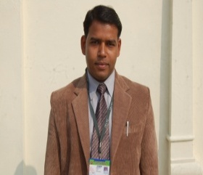
Correspondence Address:
Jahangirabad Educational Trust Group of Institutions
Jahangirabad Fort, Lucknow, India-225203
E-mail: jilani83@gmail.com, Mobile.91+9793239510

Personal Profile
Father’s Name : Mr. Abu Bakar
Date of Birth : 05 Feb. 1983
Gender : Male
Marital Status : Unmarried
Nationality : Indian
Passport no : J3342132
Permanent Address : Vill- Leduwa Mahuwa-(New Mohalla), Post. Bakhira
Distt. Sant Kabir Nagar, Uttar Pradesh, India –272159
Career Objective:
To perfect the various paradigms of Translation Services applying the skills of cultural perception and multilingual knowledge

Professional Qualification:
P.G.D. in Translation : IGNOU, New Delhi, Lucknow Regional Centre. Pursuing
D.C.A. & Multilingual DTP : DOEACC, Chandigarh, URC, Aligarh, Indi.2008
Diploma in Urdu Language : NCPUL New Delhi, URC, Aligarh, 2008

Academic Qualification:
High School- Science : UP Board, Allahabad in 1998
Intermediate- Mathematics : UP Board, Allahabad in 2000
B. A. - Economics : Gorakhpur University, Gorakhpur in 2005
M.A. – English : Maulana Azad National Urdu University, Hyderabad. Pursuing

Computer Skills:
IT, Business System, Web Application Development, In Page, Page Maker, Coral Draw, Tally, MS Office

Language Known: English, Hindi, Urdu

Hobbies: Reading, Cricket, Volleyball

I, hereby declare that all statements made in this application are true and complete to the best of my knowledge and belief.

Date: 16/08/2011
Place: Lucknow, India (Gulam Jilani)

