Gökay ÇETİN 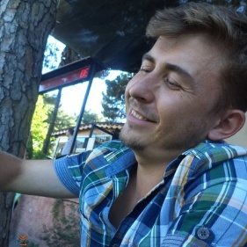
Phone: +090 536 605 21 98 E-mail: gokaycetin87@hotmail.com
Address: Toki Konutları Blok: B12 Daire:20 Kepez / ÇANAKKALE
Personal Information
Date of Birth : 10.01.1987
Place of Birth : İzmir
Obligatory Military Service : Fulfilled
Education Information
2006 – 2011 Çanakkale Onsekiz Mart University, Faculty of English Language Teaching
2001 – 2005 Dikili Multi-Programme High School, Department of Foreign Languages (English)
Job Experiences
2011 - …. Technical specifications of General Directorate of Highways and Railways; business contracts; tool, device equipment operation and maintenance manuals; technical and academic articles (medicine, engineering, physical sciences, social sciences)
2010 Technical manuals and webpage in the field of sport (healthy life) (SuperSlow Zone® Turkey, İstanbul), many academic articles (physical and social sciences, economy, medicine, literature), user guides
2008 - 2009 Many academic articles in the fields of chemistry, physics, medicine, biology, agriculture, educational sciences
References
SuperSlow Zone Turkey
TranslateMedia
Beta Translation Agency
Semantik Language Services
LingoTurk
Ingeno Consulting
Karzey Traduction
Work Experience Duration
5 years (More than 5 thousand pages)
Areas of Expertise
Economy, medicine (general), physical sciences, social sciences, informatics and information technology, educational sciences, sports and sport machines, tourism, law (agreements, court documents, etc.), user guides and manuals and similar technical manuals, brochures, booklets.

CAT Tools Used
Trados 2007 – Advanced
Trados Studio 2009-2011 – Advanced
MemoQ 5 – Advanced

Daily Capacity
Approximately 3000 words (15.000 characters)
Unit Price
Rate per word : 0,05 Dollar / 0,035 Euro (1000 characters (180 words) 6 Dollar/5 Euro)

